**HCMC UNIVERSITY OF TECHNOLOGY AND EDUCATION**

**FACULTY FOR HIGH QUALITY TRAINING**

🙤🕮🙦



**SUBJECT**

**Computer Architecture and Organization Lab**

**FINAL REPORT**

**Lecturer: PhD. Pham Van Khoa**

**Student: Le Thi Kieu Giang 19119001**

**Course ID: [COOL325364E-02CLC](https://fhqx.hcmute.edu.vn/course/view.php?id=7909" \o "Computer Architecture and Organization Lab_ Nhom 02CLC)**

**HCM City, 12/202****1**

TABLE OF CONTENTS

🙤🕮🙦

[TABLE OF CONTENTS 1](#_Toc14613)

[TABLE OF FIGURES 4](#_Toc10186)

[PART A: 8086 MPU 6](#_Toc22045)

[WEEK 1 and WEEK 2: 7](#_Toc26558)

[I. Objective 7](#_Toc31040)

[II. Requirements 7](#_Toc23805)

[III. Design and Implementation 7](#_Toc26281)

[IV. Results (code & schematic) 7](#_Toc29158)

[V. Discuss 9](#_Toc17053)

[WEEK 3: 10](#_Toc30626)

[I. Objective 10](#_Toc10184)

[II. Requirements 10](#_Toc7081)

[III. Design and Implementation 10](#_Toc7480)

[IV. Results (code & schematic) 10](#_Toc615)

[V. Discuss 14](#_Toc20727)

[WEEK 4: 15](#_Toc30685)

[I. Objective 15](#_Toc25758)

[II. Requirements 15](#_Toc28275)

[III. Design and Implementation 15](#_Toc17242)

[IV. Results (code & schematic) 15](#_Toc1379)

[V. Discuss 18](#_Toc30007)

[WEEK 5: 19](#_Toc23390)

[I. Objective 19](#_Toc16817)

[II. Requirements 19](#_Toc22354)

[III. Design and Implementation 19](#_Toc17366)

[IV. Results (code & schematic) 19](#_Toc8321)

[V. Discuss 22](#_Toc25735)

[WEEK 6: 23](#_Toc2129)

[I. Objective 23](#_Toc5007)

[II. Requirements 23](#_Toc31601)

[III. Design and Implementation 23](#_Toc7852)

[IV. Results (code & schematic) 23](#_Toc32069)

[V. Discuss 26](#_Toc15817)

[WEEK 7: 27](#_Toc1990)

[I. Objective 27](#_Toc26086)

[II. Requirements 27](#_Toc15149)

[III. Design and Implementation 27](#_Toc16531)

[IV. Results (code & schematic) 27](#_Toc25633)

[V. Discuss 29](#_Toc21476)

[PART B: 8051 MCU 30](#_Toc21577)

[WEEK 8: 31](#_Toc1852)

[I. Objective 31](#_Toc10349)

[II. Requirements 31](#_Toc21363)

[III. Design and Implementation 31](#_Toc12418)

[IV. Results (code & schematic) 31](#_Toc8477)

[V. Discuss 34](#_Toc4452)

[WEEK 9: 35](#_Toc11765)

[I. Objective 35](#_Toc13574)

[II. Requirements 35](#_Toc23226)

[III. Design and Implementation 35](#_Toc1365)

[IV. Results (code & schematic) 35](#_Toc3342)

[V. Discuss 37](#_Toc3891)

[WEEK 10: 38](#_Toc27914)

[I. Objective 38](#_Toc22053)

[II. Requirements 38](#_Toc17568)

[III. Design and Implementation 38](#_Toc9910)

[IV. Results (code & schematic) 38](#_Toc14098)

[V. Discuss 40](#_Toc25749)

[PART C: HIGH-LEVEL PROGRAMMING ON AT89C51 41](#_Toc30970)

[WEEK 11: 42](#_Toc31476)

[I. Objective 42](#_Toc13753)

[II. Requirements 42](#_Toc2242)

[III. Design and Implementation 42](#_Toc30028)

[IV. Results (code & schematic) 42](#_Toc28585)

[V. Discuss 52](#_Toc11735)

[WEEK 12: 54](#_Toc25586)

[I. Objective 54](#_Toc18014)

[II. Requirements 54](#_Toc19662)

[III. Design and Implementation 54](#_Toc15503)

[IV. Results (code & schematic) 54](#_Toc32653)

[V. Discuss 61](#_Toc28034)

[WEEK 13: 62](#_Toc30145)

[I. Objective 62](#_Toc16863)

[II. Requirements 62](#_Toc23914)

[III. Design and Implementation 62](#_Toc16328)

[IV. Results (code & schematic) 63](#_Toc7072)

[V. Discuss 66](#_Toc22901)

[WEEK 14: 67](#_Toc23884)

[I. Objective 67](#_Toc17776)

[II. Requirements 67](#_Toc28405)

[III. Design and Implementation 67](#_Toc21956)

[IV. Results (code & schematic) 68](#_Toc7085)

[V. Discuss 70](#_Toc11685)

[REFERENCES 71](#_Toc5273)

TABLE OF FIGURES

🙤🕮🙦

[Figure: Addition and Subtraction 2 numbers 8](#_Toc13139)

[Figure: Covert 2 numbers 9](#_Toc27827)

[Figure: Storage addition of 8-bits register 12](#_Toc3755)

[Figure: Survey instructions such as JMP,JLE and label 13](#_Toc429)

[Figure: Decrease/increase variable value 14](#_Toc5205)

[Figure: Add and subtract 2 numbers have 2-digits. 17](#_Toc30207)

[Figure: Enter 5 digit numbers from keyboard 18](#_Toc11790)

[Figure: Calculate and storage a 5 digit numbers into a 16-bit register 21](#_Toc12529)

[Figure: Enter n bit from keyboard and print exponential 2 22](#_Toc8329)

[Figure: Survey Shift 8-bit registers 24](#_Toc15532)

[Figure: Survey Shift 8-bit registers 26](#_Toc27757)

[Figure: Change binary to decimal and print on the screen 28](#_Toc16858)

[Figure: Change decimal to binary and print on the screen 29](#_Toc32756)

[Figure: Addition 2 number in 7-segment LED display 32](#_Toc1337)

[Figure: P2.7 equals 1, Add 2 numbers. 34](#_Toc1695)

[Figure: P2.7 equals 0, Subtract 2 numbers. 34](#_Toc7930)

[Figure : Calculating frequency and duty cycle in the first problem. 35](#_Toc20403)

[Figure : Frequency and duty cycle of second problem. 36](#_Toc8670)

[Figure: Display 7-segment LED by 2Hz 39](#_Toc18761)

[Figure: Alternating blinking LED 43](#_Toc22638)

[Figure : Single LED interface with latch circuit 45](#_Toc15678)

[Figure: Design 7-segment LED 47](#_Toc12483)

[Figure: Display 7-segment LED by IC 74LS247 Decoder 48](#_Toc9799)

[Figure: Display 7-segments LED by scan method 50](#_Toc29620)

[Figure: Scanning 7-segment LED by IC 74245 52](#_Toc26350)

[Figure: AT89C51 and Button 55](#_Toc2671)

[Figure: AT89C51 and Switch 56](#_Toc14670)

[Figure: Using interrupts to check state when single LED is changed 57](#_Toc28093)

[Figure: Using external interrupt to increase the value of LED 59](#_Toc9661)

[Figure: Creating precise delay using Timer/Interrupt 60](#_Toc29827)

[Figure: Analog Channel Selection 62](#_Toc32719)

[Figure: Time diagram 62](#_Toc9027)

[Figure: Analog to digital converter ADC 63](#_Toc9294)

[Figure: 8 the sensor temperature LM35 to measure temperature 65](#_Toc27816)

[Figure: Virtual Serial Port Driver Software 67](#_Toc18462)

[Figure: H-Term. 68](#_Toc4957)

[Figure: UART application 69](#_Toc26413)

PART A: 8086 MPU

The general purpose of this section is to help learners review some of the issues of computer architecture from using the design of a computer. In addition, the supported instruction set architectures for this family of microcontrollers are briefly outlined.

Help learners manipulate the commands supported in the script.

Examine assembly language and the meaning of the process of compiling source code into machine code.

From the basic examples, learners can understand in-depth the usage of each instruction code, the structure and influence of the registers, as well as the control programming methods such as:

- Move and exchange data, sort, exchange and find elements in arrays.

- Arithmetic processing such as addition, subtraction, multiplication, division Logical processing.

- HEX and BCD counters.

- Convert BCD, DEC, HEX digital system.

WEEK 1 and WEEK 2:

1. Objective

Learn about Assembly language.

Understand basic registers.

Understand and use MOV, INT, ADD and SUB instructions.

1. Requirements

Can use MOV and INT instructions. Study the ADD and SUB instructions and solve the problem.

Enter two 1-digit numbers from the keyboard in which the first number is larger than the second one. Calculate the addition and subtraction of them.

Algorithm:

- ADD: operand1 = operand1 + operand2.

- SUB: operand1 = operand1 - operand2.

1. Design and Implementation

We use 2 instructions as ADD and SUB to solve the requirement.

After the calculation of results from problem 1, we will change these results into numbers.

1. Results (code & schematic)

**Problem 1: Addition and Subtraction 2 numbers**

**Code:**

ORG 100H

MOV AH,1

INT 21H

MOV BH, AL

INT 21H

MOV BL, AL

SUB BX, 3030H

;----ADD

MOV CX, BX

ADD BH, BL

ADD BH, 30H

MOV AH, 2

MOV DL, BH

INT 21H

;SUB CX, 3030H

;----SUBT

SUB CH, CL

ADD CH, 30H

MOV DL, CH

INT 21H

RET

**Solution:**

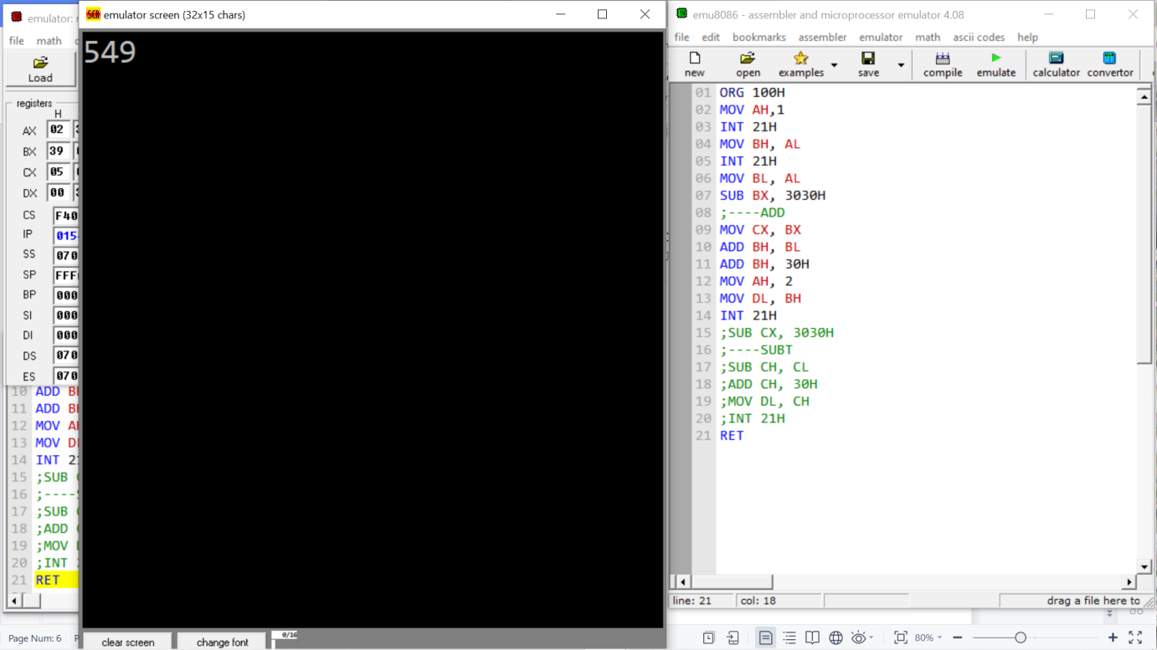

Figure: **Addition and Subtraction 2 numbers**

**Problem 2: Covert 2 numbers**

**Code:**

ORG 100H

MOV AH,1

INT 21H ;AL=37H 00110111B

MOV BH,AL

;MOV AH,1 ;DEC. CPI INC. PERF

INT 21H ;AL=32H

MOV BL,AL ;BX=|A|B| = 3732H

;'7'->7 ; '2'->2

SUB BX, 3030H ;BX=|A|B| = 0702H

ADD BH, BL ;BH=09H -> '9'

ADD BH, 30H

MOV AH, 2

MOV DL, BH

INT 21H

RET

**Solution:**

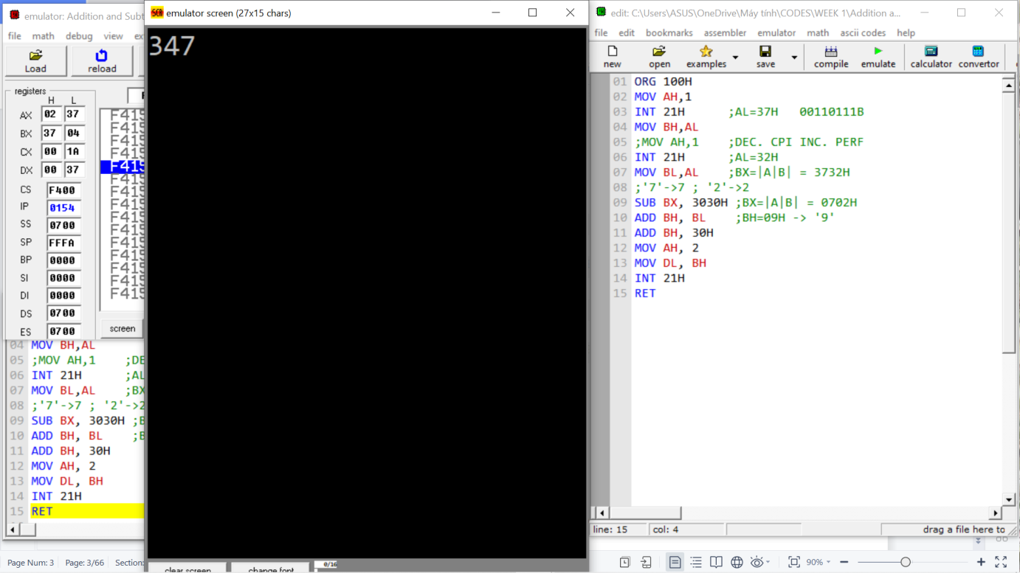

Figure: **Covert 2 numbers**

1. Discuss

Understanding Assembly programming language.

Understand and use basic registers.

After the problem, we can fluently use the MOV, INT, SUB, ADD instructions. Moreover, we can fluently use the SUB and ADD instructions and convert numbers to characters and characters to numbers.

WEEK 3:

1. Objective

Help learners continue to solve problems using ADD and SUB instruction.

Know is to store the execution result in an 8-bit register.

Know how to use labels.

1. Requirements

Solve the problem of "Input 2 digits and store in 8-bit register".

1. Design and Implementation

We will use last week's design to solve the question of "Input 2 digits and store in 8-bit register".

Store in 8-bit register using tenth division.

In this problem, we will examine the branch instruction and label structure to solve the problem of storing in 8-bit registers.

1. Results (code & schematic)

**Problem 1: Storage addition of 8-bits register**

**Code:**

ORG 100H

; NHAP SO 1

MOV AH,1

INT 21H

MOV CH,AL

INT 21H

MOV CL,AL

;CONVERT

;---------------------------------

; NHAP SO 2

INT 21H

MOV DH,AL

INT 21H

MOV DL,AL

;---------------------------------

;CONVERT

SUB CX,3030H

SUB DX,3030H

;---------------------------------

MOV AL, 10

MUL CH

ADD AL, CL

; GAN GIA TRI TAM THOI

MOV BH,AL ; BH= SO THU 1

;---------------------------------

MOV AL, 10

MUL DH

ADD AL, DL

; GAN GIA TRI TAM THOI

MOV BL,AL ; BL = SO THU 2

;---------------------------------

MOV CX,BX

;PHEP TINH ADD/SUB

ADD BH,BL ; CONG BH=BH+BL

;ADD BL,BH ; CONG BL=BH+BL

;MOV AL,BH

;---------------------------------

SUB CH,CL ; CH=CH-CL

;MOV BL,CH ; GAN BL = CH

;---------------------------------

; PHEP CONG

MOV AL,BH

MOV DL,10

DIV DL

MOV BL,AH

MOV AH,0

DIV DL

;--------------------------

MOV CL,AH

MOV AH,2

MOV DL,AL

ADD DL,30H

INT 21H

MOV DL,CL

ADD DL,30H

INT 21H

MOV DL,BL

ADD DL,30H

INT 21H

; PHEP TRU

MOV AX,0H

MOV AL,CH

MOV DL,10

DIV DL

MOV BL,AH

MOV AH,0

DIV DL

;------------------------

MOV CL,AH

MOV AH,2

MOV DL,AL

ADD DL,30H

INT 21H

MOV DL,CL

ADD DL,30H

INT 21H

MOV DL,BL

ADD DL,30H

INT 21H

RET

Solution:

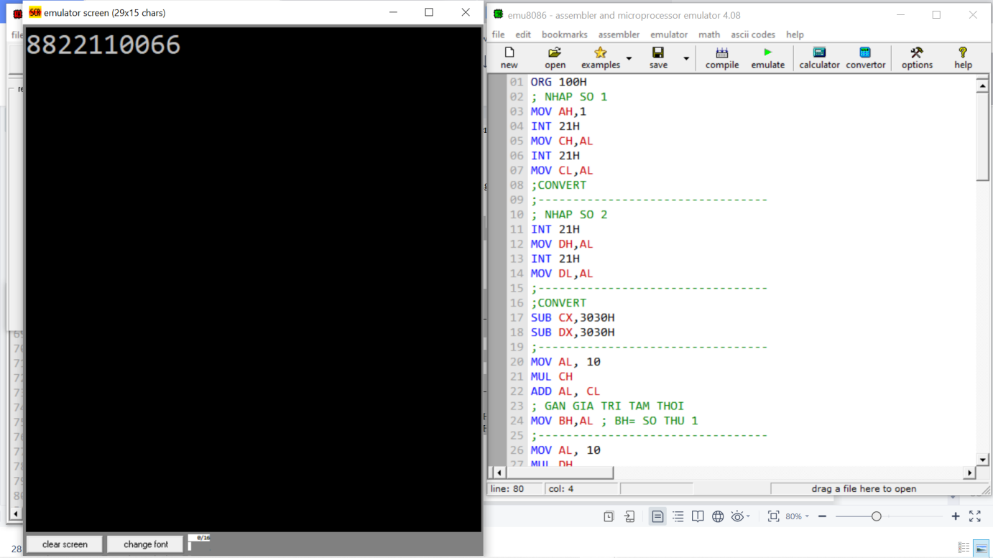

Figure: Storage addition of 8-bits register

**Problem 2: Survey instructions such as JMP,JLE and label.**

**Code:**

ORG 100H

MOV AH,1

INT 21H

MOV BH,31H

CMP BH,AL

JLE STAGE1

JMP EXIT

STAGE1:

MOV AH,2

MOV DL,AL

INT 21H

INC BH

CMP BH,AL

JLE STAGE1

JMP EXIT

EXIT:

RET

**Solution:**

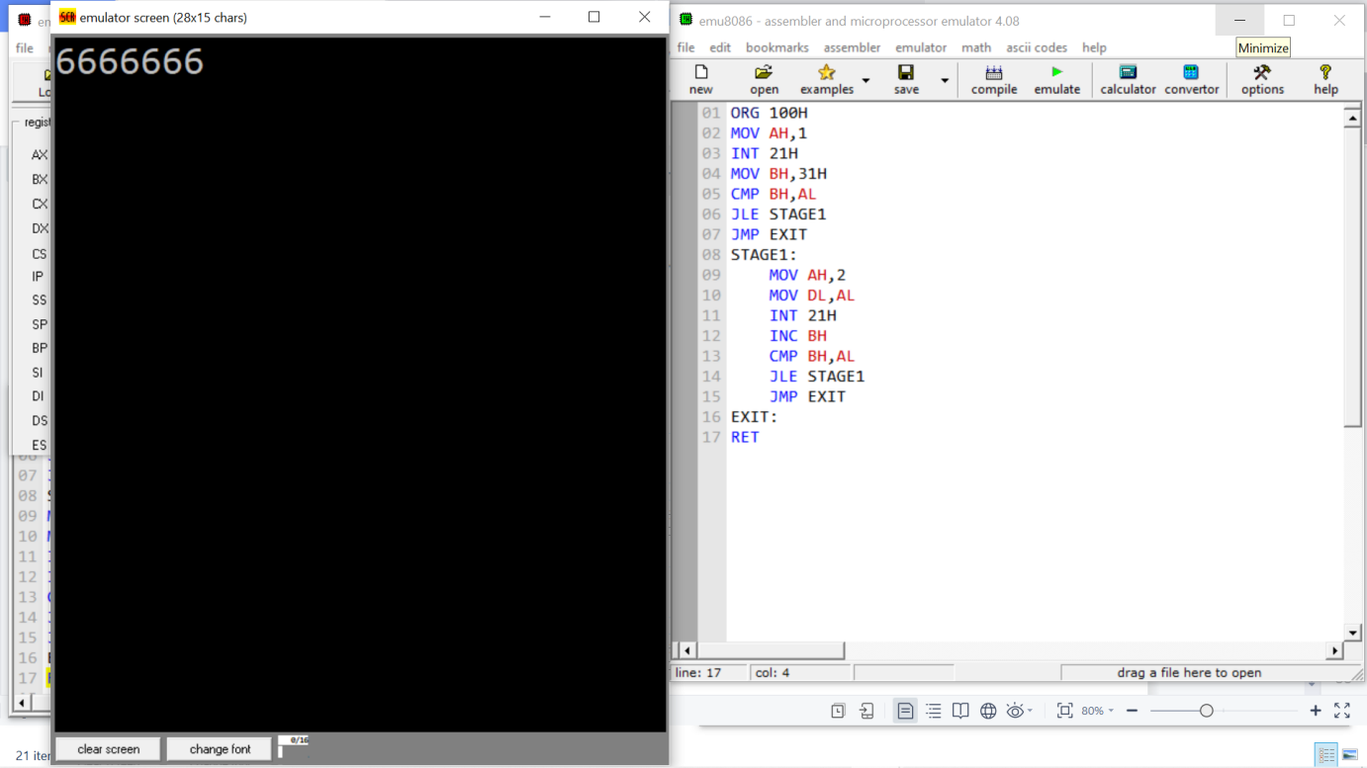

Figure: Survey instructions such as JMP,JLE and label

**Problem 3: Applying branching structure to decrease/increase variable value**

**Code:**

ORG 100H

MOV AH,1

INT 21H

CMP AL,35H

JG DECCASE

JLE INCCASE

DECCASE:

CMP AL,30H

JE EXIT

DEC AL

MOV AH,2

MOV DL,AL

INT 21H

JGE DECCASE

INCCASE:

CMP AL,39H

JE EXIT

INC AL

MOV AH,2

MOV DL,AL

INT 21H

JGE INCCASE

EXIT:

RET

**Solution:**

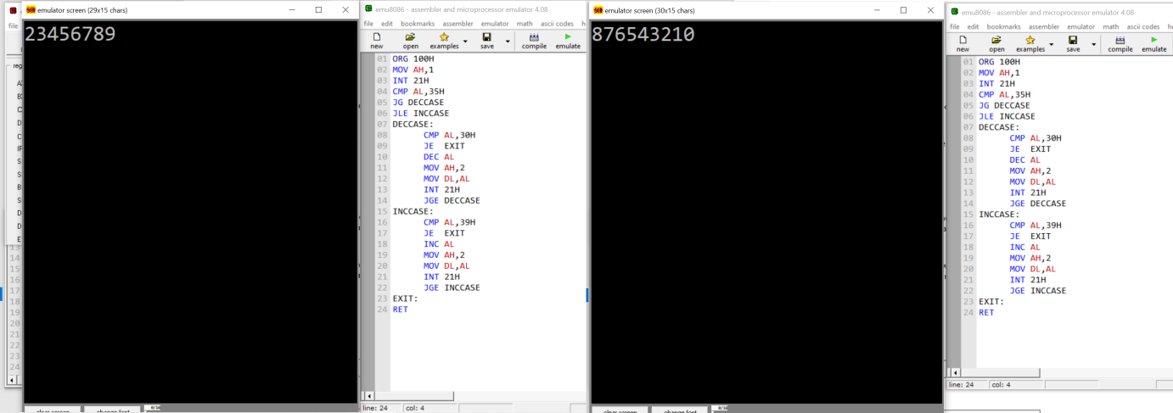

Figure: Decrease/increase variable value

1. Discuss

We know how to store data in 8-bit registers and examine the principle of branching and label structures.

Understand and use labels well.

Sorting algorithm is more optimal.

WEEK 4:

1. Objective

Survey MUL and DIV instructions.

1. Requirements

Study and can use MUL and DIV instructions to solve the problem.

Algorithm:

MUL:

- When operand is a byte: AX = AL \* operand.

- When operand is a word: (DX AX) = AX \* operand.

DIV:

- When operand is a byte: AL = AX / operand.

AH = remainder (modulus).

- When operand is a word: AX = (DX AX) / operand DX = remainder (modules).

1. Design and Implementation

Survey the MUL and DIV instructions.

Applying multiple and division solve the problems such as storing 0 to 4 digit numbers in the 16-bit register and entering 5 digit numbers from Keyboard.

1. Results (code & schematic)

**Problem 1: Enter 2 numbers have 2 digits. Calculate the addition and subtraction, print the result to the screen.**

**Code:**

ORG 100H

;1ST NUMBER

MOV AH,1

INT 21H

SUB AL,30H

MOV DH,10

MUL DH

MOV BL,AL

MOV AH,1

INT 21H

SUB AL,30H

ADD BL,AL

;2ND NUMBER

MOV AH,1

INT 21H

SUB AL,30H

MOV DH,10

MUL DH

MOV BH,AL

MOV AH,1

INT 21H

SUB AL,30H

ADD BH,AL

;TONG

MOV AX,BX

ADD AL,AH

MOV AH,0

DIV DH

MOV CL, AH

MOV AH,0

DIV DH

MOV DX,AX

;IN RA MAN HINH TONG

MOV AH,2

ADD DL,30H

INT 21H

MOV DL,DH

ADD DL,30H

INT 21H

MOV DL,CL

ADD DL,30H

INT 21H

;HIEU

MOV AX,BX

SUB AL,AH

MOV DH,10

MOV AH,0

DIV DH

MOV BX,AX

;IN RA MAN HINH HIEU

MOV AH,2

MOV DL,BL

ADD DL,30H

INT 21H

MOV DL,BH

ADD DL,30H

INT 21H

RET

**Solution:**

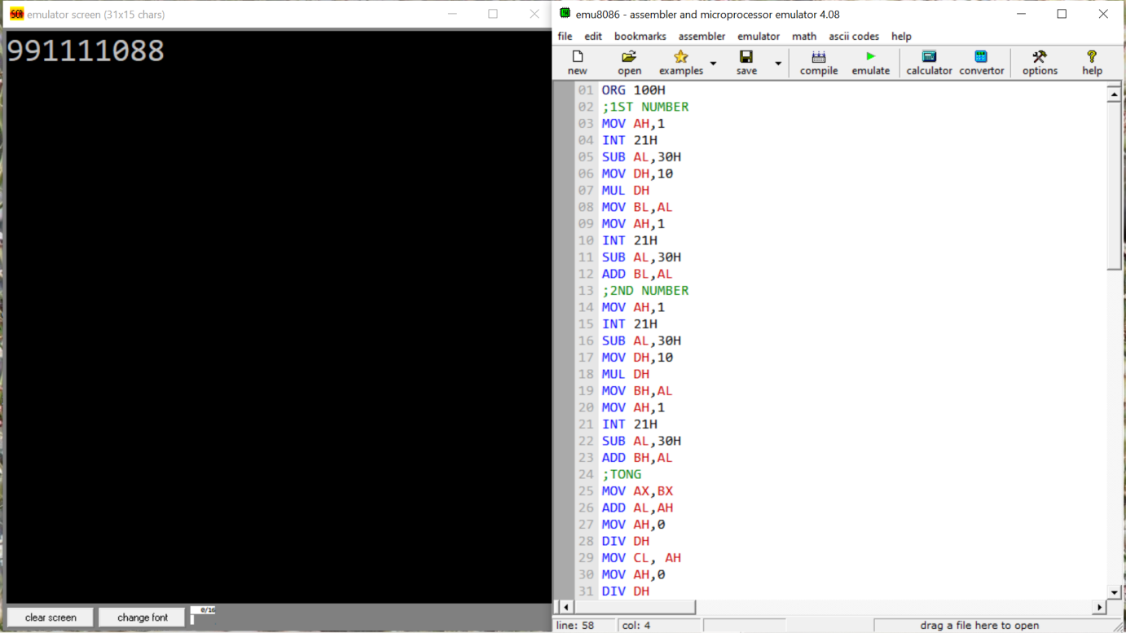

Figure: Add and subtract 2 numbers have 2-digits.

**Problem 2: Enter 5 digit numbers from keyboard**

**Code:**

MOV CX, 0AH

INP: MOV AH, 1

INT 21h

SUB AL, 30h

MOV BH, AL

CMP BH, 5h

JG Error

CMP BH, 1H

JL Error

MOV DL, 'T'

MOV AH, 2

INT 21H

MOV DX, 0

COMP:

CMP BH, 1

JL EXIT

MOV AX, DX

MUL CX

MOV DX, AX

MOV AH, 1

INT 21h

SUB AL, 30h

MOV AH, 0

ADD DX, AX

DEC BH

JMP COMP

Error:

MOV DL, 'F'

MOV AH, 2

INT 21H

JMP INP

EXIT:

MOV CX, DX

MOV DL, 'D'

MOV AH, 2

INT 21H

**Solution:**

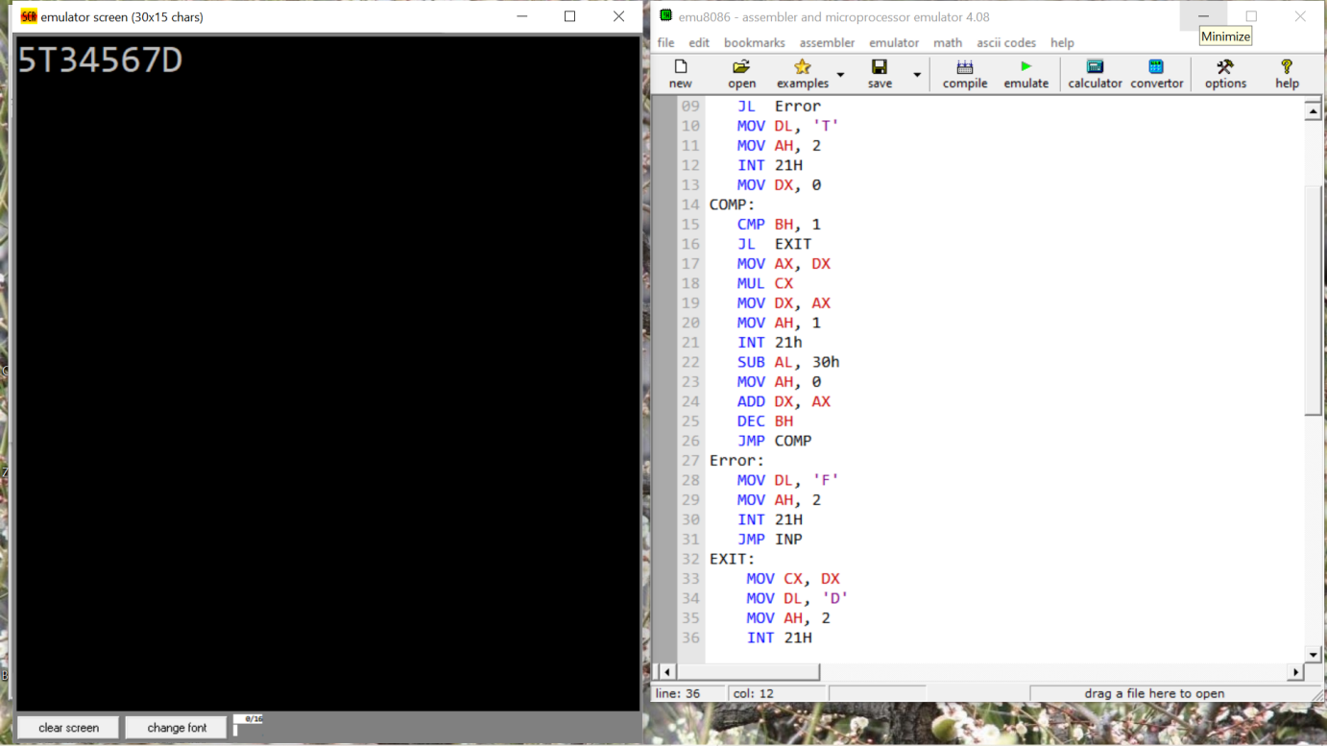

Figure: Enter 5 digit numbers from keyboard

1. Discuss

We can understand how to use multiples and divides in Assembly to solve questions. Furthermore, learners can design a basic math problem using a combination of instructions.

WEEK 5:

1. Objective

Introduction to POP and PUSH instructions.

Transfer memory to the Stack using the POP and PUSH instructions.

Survey OR, XOR và AND.

Introduction to ROL and SHL instructions.

1. Requirements

Solve problems like “Calculating 2n with n:bits”, “Calculating addition or subtraction and storing in 16 bit registers”.

Complete investigation of instructions such as OR, XOR, AND gates and apply the investigated transform in the problem.

Algorithm:

- POP: operand = SS: [SP] (top of stack) SP = SP + 2

- PUSH: SP = SP - 2 SS: [SP] (top of stack) = operand

1. Design and Implementation

The problem: “Calculate and store 5-digit numbers into 16-bit registers”, uses the POP and PUSH instructions to create loop storage and handle between multiples of tenths and addition after multiples.

The problem: “Input n bits from the keyboard and print exponential 2”, the main aim in the design is a combination of LIFO method and ROL and SHL instructions.

1. Results (code & schematic)

**Problem 1: Calculate and storage a 5 digit numbers into a 16-bit register.**

**Code:**

MOV BL, 2H

MAIN:

CMP BL, 1H

MOV CX, 0H

JGE Inp

JMP Sum\_Sub

Store:

MOV CX, DX

PUSH CX

DEC BL

MOV AH, 2

MOV DL, 'D'

INT 21H

JMP MAIN

Sum\_Sub:

POP BX

POP CX

PUSH BX

ADD BX, CX

POP DX

SUB CX, DX

MOV AX,BX ;Start print

RET

Inp:

MOV AX, 00H

MOV DX, 00H

MOV AH, 1

INT 21h

SUB AL, 30h

MOV BH, AL

JMP Condition

Error:

MOV AH, 2

MOV DL, 'N'

INT 21h

JMP Inp

Condition:

CMP AL, 0H

JE Error

CMP BH, 4h

JG Error

Execute:

CMP BH, 0H

JE Exit

MOV AH, 1

INT 21h

MOV CL, AL

SUB CL, 30h

MOV AX, 000Ah

MUL DX

MOV DX, AX

ADD DX, CX

DEC BH

JMP Execute

Exit:

CMP BL, 2H

JLE Store

**Solution:**

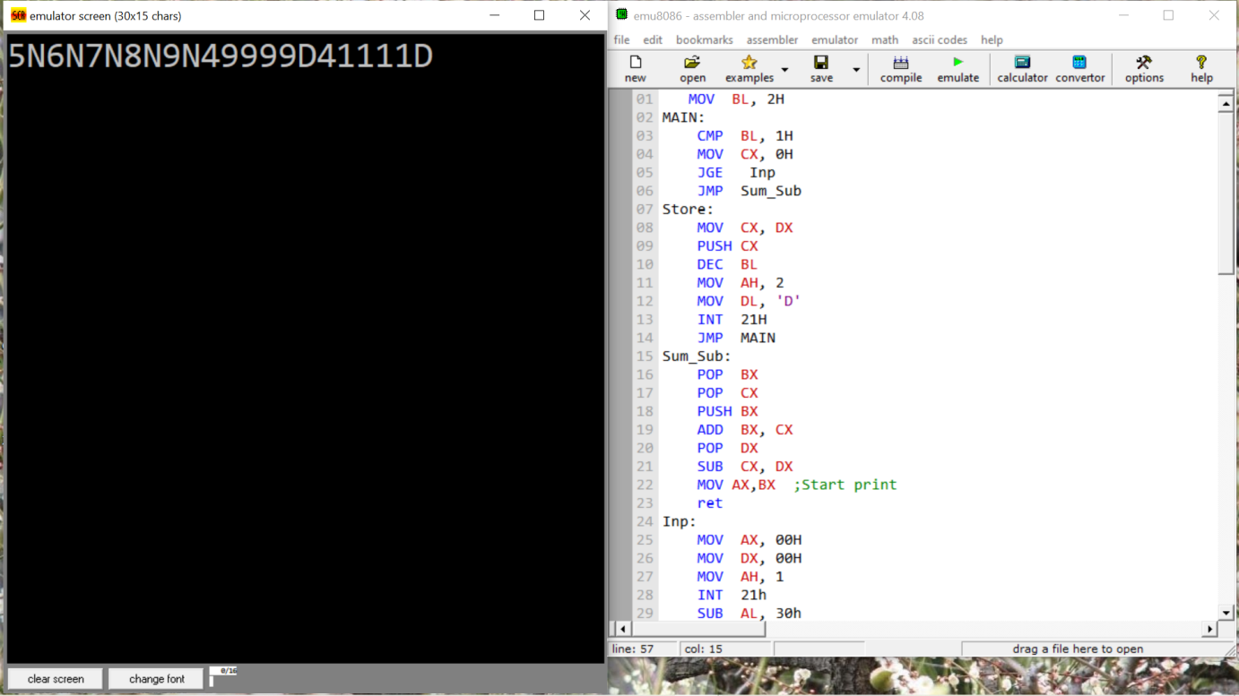

Figure: Calculate and storage a 5 digit numbers into a 16-bit register

**Problem 2: Enter n bit from keyboard and print exponential 2.**

**Code:**

INP: MOV AH, 1

INT 21H

CMP AL, 30H

JL ERROR

CMP AL, 39H

JG ERROR

MOV CL, AL

AND CL, 0FH

MOV AX, 01H

ROL AX, CL

XOR CL, CL

OR BX, 10

OUTPUT:

XOR DX, DX

DIV BX

PUSH DX

INC CL

CMP AX, 0

JE PRINT

JMP OUTPUT

PRINT:

POP DX

OR DL, 30H

MOV AH, 2

INT 21H

DEC CL

CMP CL, 0

JE COMPLETE

JMP PRINT

ERROR: MOV DL, 'N'

MOV AH, 2

INT 21H

JMP INP

COMPLETE:

**Solution:**

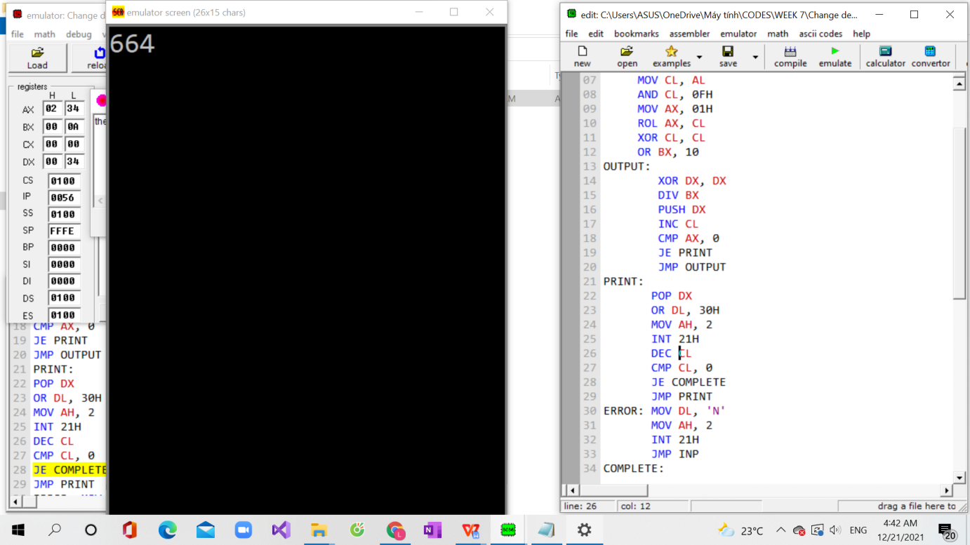

**Figure: Enter n bit from keyboard and print exponential 2**

1. Discuss

Understanding LIFO method.

Understand and use POP and PUSH instructions.

Understand and use ROL and SHL instruction with which we can move any bit in the register.

Manipulate and replace instructions to optimize the algorithm.

WEEK 6:

1. Objective

Introduction to SHL, SHR, ROL, ROR instructions.

Survey SHL, SHR, ROL, ROR instructions.

1. Requirements

Study SHL, SHR, ROL, ROR instructions:

For SHL, SHR:

Algorithm:

- Shift all bits left, the bit that goes off is set to CF.

- Zero bit is inserted to the right-most position.

For ROL, ROR:

Algorithm:

- Shift all bits left, the bit that goes off is set to CF, and the same bit is inserted to the right-most position.

1. Design and Implementation

Solve a basic problem: “Survey 8-bit Register Shift and 16-bit Register Shift”.

1. Results (code & schematic)

**Problem 1: Survey Shift 8-bit registers**

**Code:**

MOV BH,8

MOV CL,0

INPUT:

MOV AH,1

INT 21H

SUB AX,0030H

MOV AH,0H

PUSH AX

INC CL

DEC BH

CMP BH,0H

JNE INPUT

MOV CH,CL

MOV CL,0H

SUM:

POP AX

SHL AX,CL

INC CL

ADD DX,AX

MOV BX,DX

CMP CH,CL

JNE SUM

MOV AX,DX ; GAN AX VA CX

MOV BX,10

XOR CL,CL

CHIA:

XOR DX,DX

DIV BX

PUSH DX

INC CL

CMP AX,0

JNE CHIA

PRINT:

POP DX

ADD DX,0030H

MOV AH,2

INT 21H

CMP CL,0

DEC CL

JNE PRINT

RET

**Solution:**

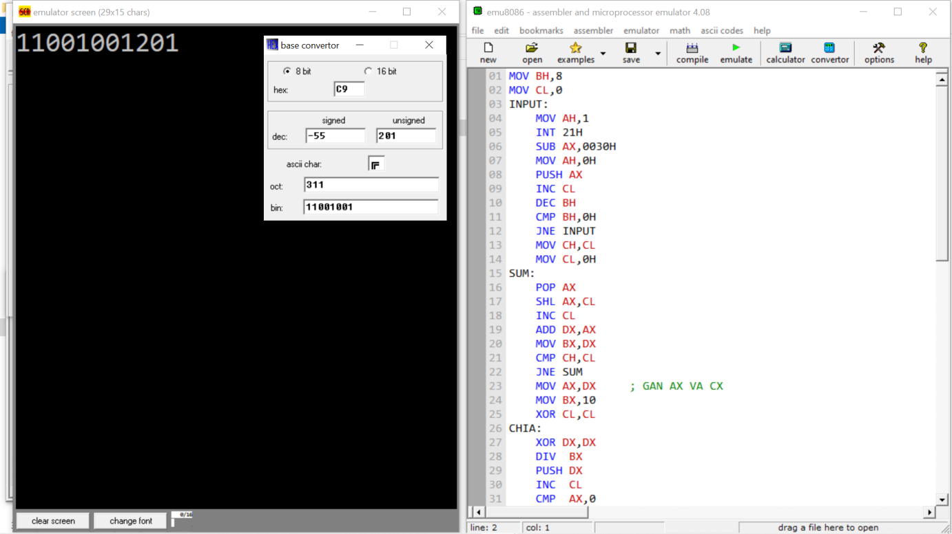

Figure: Survey Shift 8-bit registers

**Problem 2: Survey Shift 16-bit registers**

**Code:**

INPUT: MOV AH, 1H

INT 21H

CMP AL, 31H

JE SAVE

CMP AL, 30H

JE SAVE

CMP AL, 'b'

JE OUTPUT

JMP DEL

SAVE: AND AL, 0FH

XOR AH, AH

SHL DX, 1

ADD DX, AX

JMP INPUT

DEL: XOR DX, DX

JMP INPUT

OUTPUT: MOV AX, DX

;JMP OUT1

OUT1: MOV BX, 10

XOR DX, DX

DIV BX

PUSH DX

INC CL

CMP AX, 0

JE PRINT

JMP OUT1

PRINT: POP DX

OR DL, 30H

MOV AH, 2

INT 21H

DEC CL

CMP CL, 0

JE EXIT

JMP PRINT

EXIT:

**Solution:**

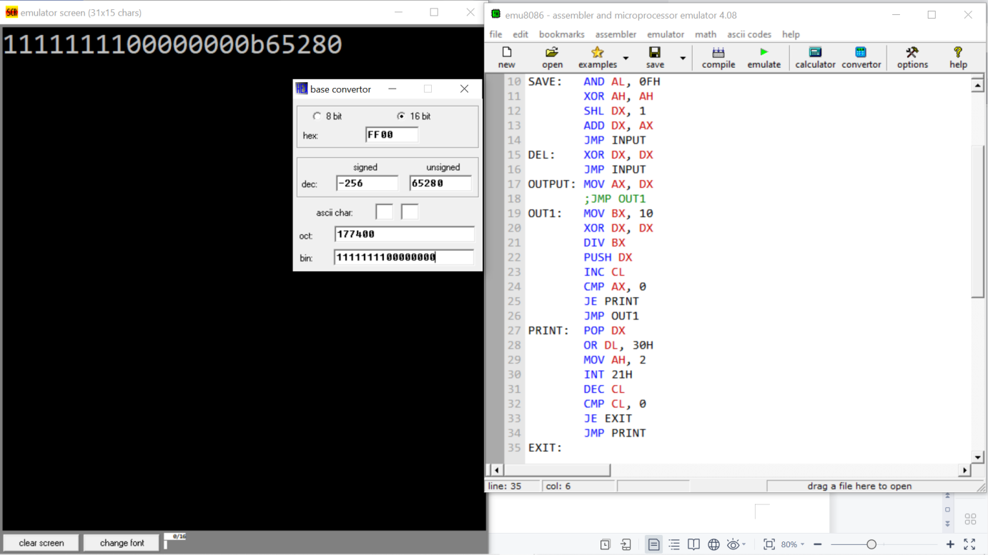

Figure: Survey Shift 8-bit registers

1. Discuss

Understand the knowledge of 8-bit and 16-bit register transfers and rotations.

Learners can use ROL, SHL, ROR and SHR to solve some questions such as “Designing an exponential circuit”,…

Manipulate and replace instructions to optimize the algorithm.

WEEK 7:

1. Objective

Review and solve problems using learned instructions.

1. Requirements

Understand and use well learned instructions.

Solve the problem by the best method.

1. Design and Implementation

The problem: “Change binary to decimal and print on the screen”.

The problem: “Change decimal to binary and print on the screen”.

1. Results (code & schematic)

**Problem 1: Change binary to decimal and print on the screen**

**Code:**

OR CL, 16

INP: MOV AH, 1

INT 21H

CMP AL, 62H

JE CAL

CMP AL, 30H

JL ERROR

CMP AL, 31H

JG ERROR

AND AL, 0FH

XOR AH, AH

ROL BX, 1

OR BX, AX

DEC CL

CMP CL, 0

JE CAL

JMP INP

ERROR: MOV DL, 'F'

MOV AH, 2

INT 21H

XOR DX, DX

JMP INP

CAL: XOR CX, CX

MOV AX, BX

MOV BX, 0AH

OUTPUT: XOR DX, DX

DIV BX

PUSH DX

INC CL

CMP AX, 0

JE PRINT

JMP OUTPUT

PRINT: POP DX

OR DL, 30H

MOV AH, 2

INT 21H

DEC CL

CMP CL, 0

JE COMPLETE

JMP PRINT

COMPLETE: RET

**Solution:**

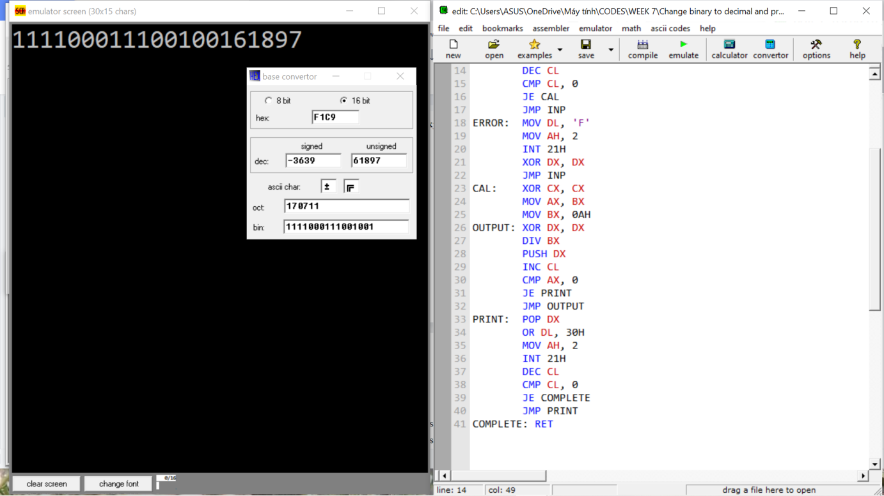

Figure: **Change binary to decimal and print on the screen**

**Problem 2: Change decimal to binary and print on the screen**

**Code:**

INPUT: MOV AH, 1

INT 21H

CMP AL, 'd'

JE CONT

MOV CL, AL

SUB CX, 0030h

MOV AX, 000Ah

MUL DX

MOV DX, AX

ADD DX, CX

INC BH

CMP BH, 4

JNE INPUT

CONT: MOV BX,DX

CONVERT:ROL BX,1

MOV DL,01H

AND DX,BX

OR DL,30H

MOV AH,2

INT 21H

INC CH

CMP CH,16

JNE CONVERT

EXIT:

**Solution:**

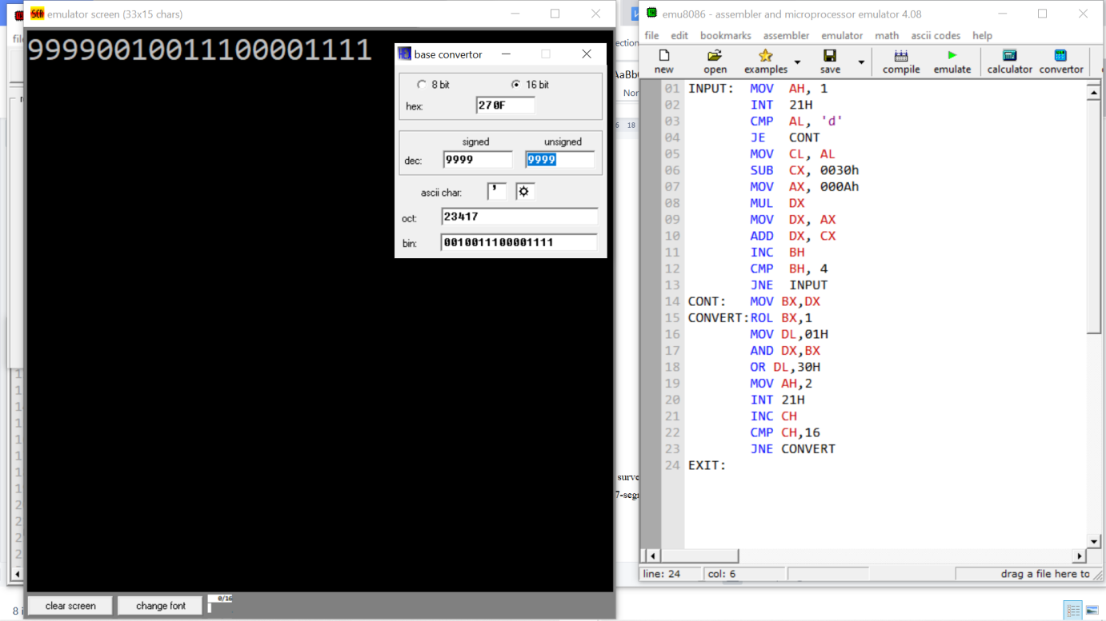

**Figure: Change decimal to binary and print on the screen**

1. Discuss

Understand combinations using instructions and solve basic problems optimally.

Know, understand and apply low-level language well to communicate with computers.

Learners can understand and convert binary and decimal numbers.

PART B: 8051 MCU

Introduction to microcontroller communication and basic I/O peripherals such as single switch/LED.

Introduces the basic arithmetic instructions for addition and subtraction, comparison and branching instructions supported in the microprocessor ALU.

Understand microcontroller communication and basic I/O peripherals like single switch/LED.

The general purpose of this section is to help learners use the instructions supported in the instruction set of the 8051 family of microcontrollers to build basic peripheral device control and communication programs. such as single LED, 7 segment LED, matrix key, ...

WEEK 8:

1. Objective

Introducing EDSIM software.

Introduction of 8051 architecture by EDSIM software.

Introduction to the instructions for moving and exchanging data on the 8051 family of microcontrollers.

Introduction to arithmetic operations and calculations.

Write basic code and connect to peripherals.

1. Requirements

Understand instructions to move and exchange data in memory.

Understand how to connect any PORT in 8051 to any peripheral.

Design a simple firmware program using assembly language for 8051 family microcontrollers to perform data transfer and exchange.

1. Design and Implementation

Design circuit, control to connect any PORT with 7-seg LED, single LED… in Assembly language.

1. Results (code & schematic)

**Problem 1: Write a program taking the addition of 2 4-bit binary numbers to display to any 7 segment-LED. 2 binary numbers are defined by a switch in P2.**

**Code:**

MOV 40H, #0C0h

MOV 41H, #0f9h

MOV 42H, #0a4h

MOV 43H, #0b0h

MOV 44H, #99h

MOV 45H, #92h

MOV 46H, #82h

MOV 47H, #0f8h

MOV 48H, #80h

MOV 49H, #90h

MOV A, P2

; 01110010 A=2; B=7

MOV 30H, A

ANL 30H, #0FH ;NUMBER A

ANL A, #0F0H

SWAP A ;NUMBER B

ADD A, 30H

ORL A, #40H

MOV R0, A

MOV A, @R0

MOV P1, A

**Schematic:**

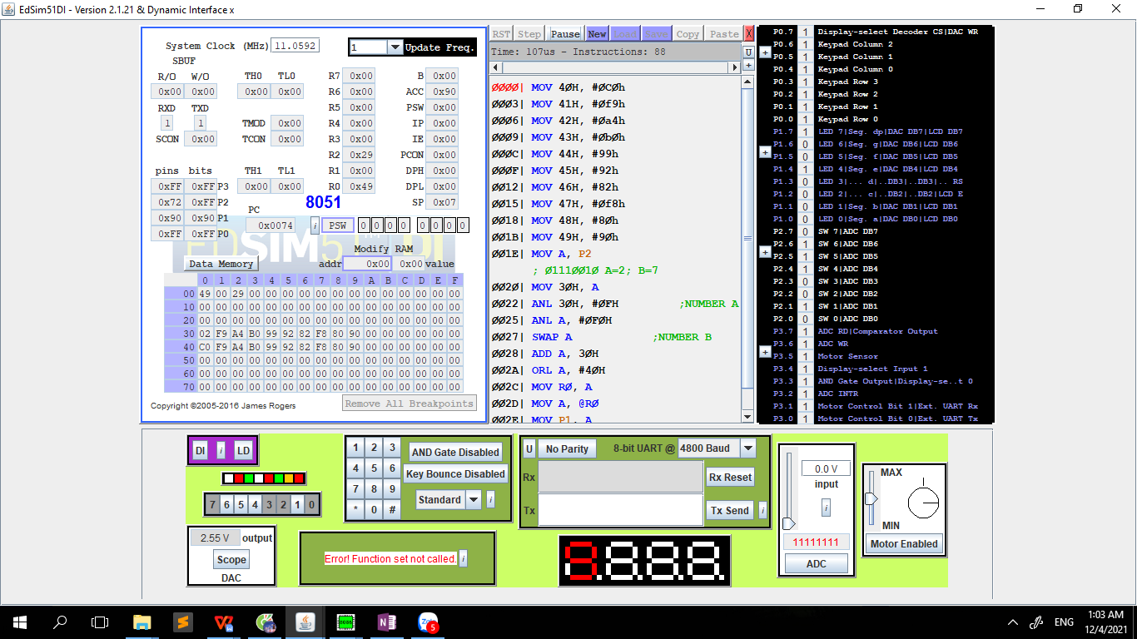

Figure: Addition 2 number in 7-segment LED display

**Problem 2: Enter 2 numbers A, B (3-bit) using P2 in which switch 3 is not used and switch 7 is used to compare. B ranges from switch 6-4 and A ranges from switch 2-0.**

**Code:**

MOV 30H,#0C0H

MOV 31H,#0F9H

MOV 32H,#0A4H

MOV 33H,#0B0H

MOV 34H,#99H

MOV 35H,#92H

MOV 36H,#82H

MOV 37H,#0F8H

MOV 38H,#80H

MOV 39H,#90H ;NUMER OF LED

MOV A,P2

ANL A,#70H

SWAP A

MOV 41H,A ;NUMBER 1

MOV A,P2

ANL A,#07H

MOV 42H,A ; NUMER 2

JB P2.7, CONG

JNB P2.7, TRU

CONG: ; CONG 2 SO

MOV A, 41H

ADD A, 42H

MOV 43H, A

JB P2.7, CHIA

TRU: ; TRU 2 SO NUM1>NUM2

MOV A, 41H

SUBB A, 42H

MOV 43H, A

JB P2.7,PRINT

CHIA:

MOV A,43H

MOV B,#10

DIV AB

MOV 41H,A

MOV 42H,B

MOV R2,#70

PRINT: ; PRINT SCAN LED

MOV A,41H

ORL A,#30H

MOV R0,A

MOV A,@R0 ; CHUC

CLR P0.7

MOV P1,A

MOV P3,#18H

SETB P0.7

MOV A,42H ; DON VI

ORL A,#30H

MOV R0,A

MOV A,@R0

CLR P0.7

MOV P1,A

MOV P3,#10H

SETB P0.7

DJNZ R2,PRINT

**Schematic:**

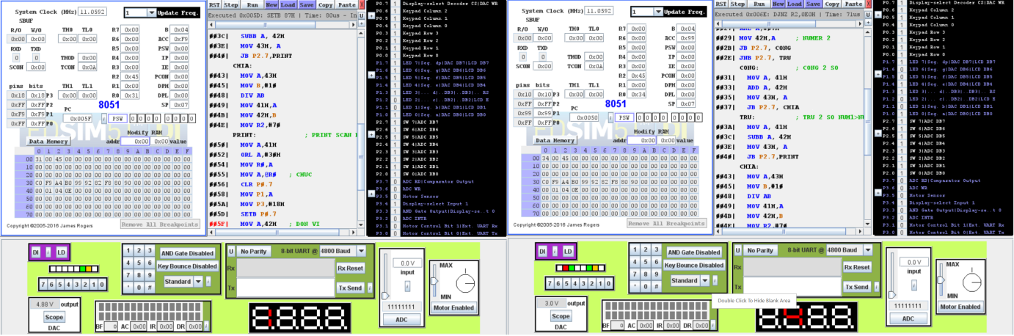

Figure: P2.7 equals 1, Add 2 numbers.

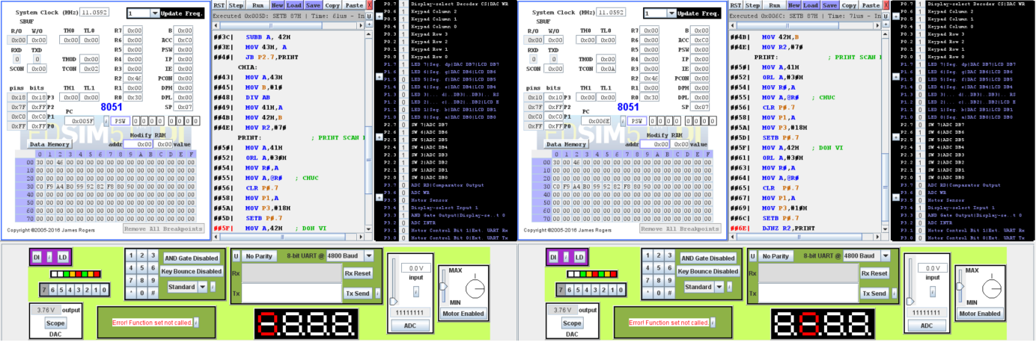

Figure: P2.7 equals 0, Subtract 2 numbers.

1. Discuss

Explain the meaning of instructions and the change in values in the registers in the program.

Understand the arithmetic operations/calculation instructions supported on the processor.

Use the assembly language for 8051 family microcontrollers to perform basic calculations such as addition/subtraction/multiplication/division.

WEEK 9:

1. Objective

Understand and write a program that generates cyclic pulses with the highest possible frequency and calculates frequency and duty cycle.

1. Requirements

Calculate the number of machine cycles required to execute the program.

1. Design and Implementation

We use IC 8051, buttons, switches and 7-seg LED to simulate a basic circuit. And we have an Oscilloscope module to measure the frequency of the PORT.

1. Results (code & schematic)

**Problem 1: Survey SET and CLR bit with P1.0**

**Code:**

ORG 8100H

LOOP: SETB P1.0

CLR P1.0

SJMP LOOP

END

**Problem 2: Calculate frequency and duty cycle**

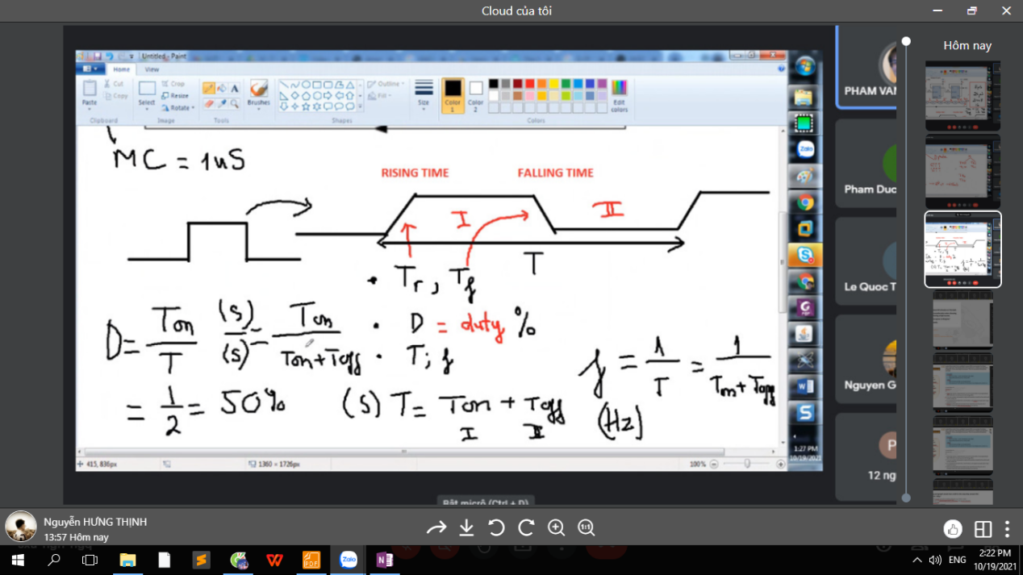

Figure : Calculating frequency and duty cycle in the first problem.

**Problem 3: Write a program with D=50%, calculate the frequency.**

**Code:**

LOOP:

SETB P1.0

NOP

NOP

CLR P1.0

SJMP LOOP

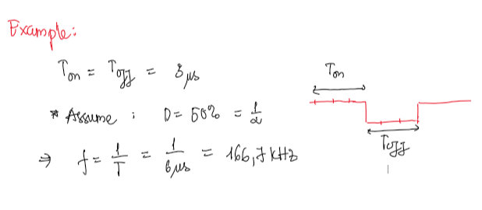

Figure : Frequency and duty cycle of second problem.

**Problem 4: Write a program creating 100KHz with D=50%.**

**Code:**

Loop:

SETB P1.0

NOP

NOP

NOP

NOP

CLR P1.0

JMP Loop

**Problem 5:** **Write a program creating 10KHz with D=50%.**

**Code:**

org 0100h

Start:

MOV TMOD, #02H

MOV TL0, #0D3H

SETB TR0

Loop:

JNB TF0, Loop

CPL P1.0

CLR TF0

MOV TL0, #0D3H

JMP Loop

END

**Problem 6:** **Write a program creating 1KHz with D=50%.**

**Code:**

org 0100h

Start:

MOV TMOD, #01H

MOV TH0, #0FEH

MOV TL0, #13H

SETB TR0

Loop:

JNB TF0, Loop

CPL P1.0

CLR TF0

MOV TH0, #0FEH

MOV TL0, #13H

JMP Loop

END

**Problem 7:** **Write a program creating 1Hz with D=50%.**

**Code:**

org 0100h

Start:

MOV TMOD, #01H

MOV TH0, #03CH

MOV TL0, #0B8H

SETB TR0

MOV R0, #0AH

Loop:

JNB TF0, Loop

CLR TF0

MOV TH0, #03CH

MOV TL0, #0B8H

DJNZ R0, Loop

CPL P1.0

MOV R0, #0AH

SJMP Loop

END

1. Discuss

Understand what principle of the timer is active and the calculation of frequency Timer.

Generate pulses of different frequencies with duty cycle = 50%.

Design and run basic circuits.

WEEK 10:

1. Objective

Solved the problem was "Display 7-segment LED by 2Hz".

1. Requirements

Explain the meaning of instructions and changes in values in registers.

Calculate the number of machine cycles required to execute the program.

1. Design and Implementation

We use IC 8051, buttons, switches and 7-seg LEDs to simulate a basic circuit. And we have an Oscilloscope module to measure the frequency of the PORT.

The frequency will determine the speed of the 7-seg LED.

1. Results (code & schematic)

**Code:**

org 0000h

jmp Start

START:

MOV 30H, #0C0h

MOV 31H, #0F9h

MOV 32H, #0A4h

MOV 33H, #0B0h

MOV 34H, #99h

MOV 35H, #92h

MOV 36H, #82h

MOV 37H, #0F8h

MOV 38H, #80h

MOV 39H, #90h

CLR P1.0

MOV R0,30H

GIVE:

MOV P3, @R0

JB P2.0, SUB

JNB P2.0,PLUS

CONS:

MOV R1,#5

SET\_TIMER:

MOV TMOD,#01H

MOV TH0, #3CH

MOV TL0, #0B0H

SETB TR0

LOOP:

JNB TF0, LOOP

CLR TF0

DJNZ R1, SET\_TIMER

CPL P1.0

SJMP GIVE

PLUS:

MOV A,R0

ANL A,#0FH

INC A

MOV R3,A

CJNE R3,#10,SET\_A0

MOV R3,#0H

MOV A,#0

JMP SET\_A0

SUB:

MOV A,R0

ANL A,#0FH

MOV R3,A

JZ SET\_A

DEC A

SJMP OUT

SET\_A0: SJMP OUT

SET\_A: MOV A,#9

OUT:

ORL A,#30H

MOV R0,A

SJMP CONS

END

**Schematic:**

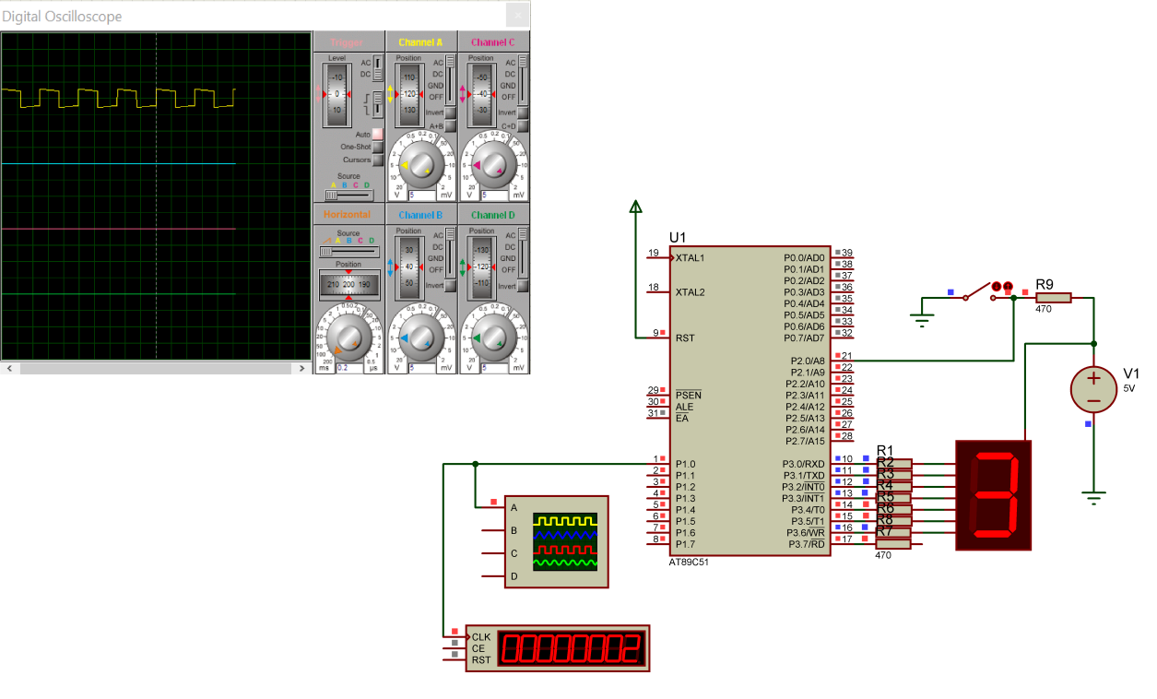

Figure: Display 7-segment LED by 2Hz

1. Discuss

Understand and apply how to communicate between 8051 and peripheral devices using Assembly language using Timers, 7-seg LED, …

Generates a pulse with a frequency of 2Hz.

Design and connect peripheral devices.

PART C: HIGH-LEVEL PROGRAMMING ON AT89C51

For the past 10 weeks, we have learned and practiced Assembly language on emu8086 software.

From week 11, we will examine microcontrollers (specifically 8051 microcontrollers) using C programming language.

The general purpose of this section is to apply the high-level programming language C to program microcontrollers. The examples are intended to help us access the internal hardware structure of this type of computer. This section will cover more about the diversification of peripheral devices that can be connected to computers on the 8051 family chip as well as issues illustrating memory expansion communication. In addition, communication and data exchange between general purpose computers and computers on the 8051 family are also covered in this section.

From the basic examples provided in this section, we can understand in depth the usage of each instruction code, the structure and influence of the registers, as well as the control programming method when executing the instructions tasks from a computer on the 8051 chip.

We programmed 8051 microcontroller to communicate with peripheral devices such as 7-segment LED, LCD, scan LED, Buttons, LM35, ... by Proteus Software and Keli C V5.

WEEK 11:

1. Objective

Introduction to microcontroller interface and single LED peripheral in different forms.

Introduction to some simple effects that can be done with single LED.

1. Requirements

Understand microcontroller interface and single LED peripheral.

Design a simple firmware program using C high level programming language for 8051 family microcontrollers (computer on chip) to interface with single LED.

Know how to analyze and select the value for the LED connection resistor if the supply voltage VDD is 5V.

Understand the function of delay function in delay source code.

1. Design and Implementation

Single LED

We write a function to set delay time for displaying LED in each case in alternating blinking.

We export or set P0 = 0x55 and delay about 100ms. After that, it changes to next case which at P0 = 0xAA.

7-segment LED

We create an array which contain hexadecimal numbers to export to 7-segment LED by PORT 0 and PORT 2.

Next, we have 2-segment LEDs for unit and decimal numbers in order to need to create 2 function decoder and display. Decoder usually use to distinguish between unit and decimal numbers by division of remainder and quotient respectively.

Finally, we base on the 2 functions above and an array to write the displaying 7-segment LED in the main function.

1. Results (code & schematic)
2. **Single LED**

**Problem 1: Design a single LED communication principle diagram by low-level LED active method.**

**Code:**

#include <at89x51.h>

void delay(int interval)

{

int i,j;

for(i=0;i<255;i++)

{

for(j=0;j<interval;j++);

}

}

void main()

{

while(1)

{

P0=0x55;

delay(100);

P0=0xAA;

delay(100);

}

}

**Schematic:**

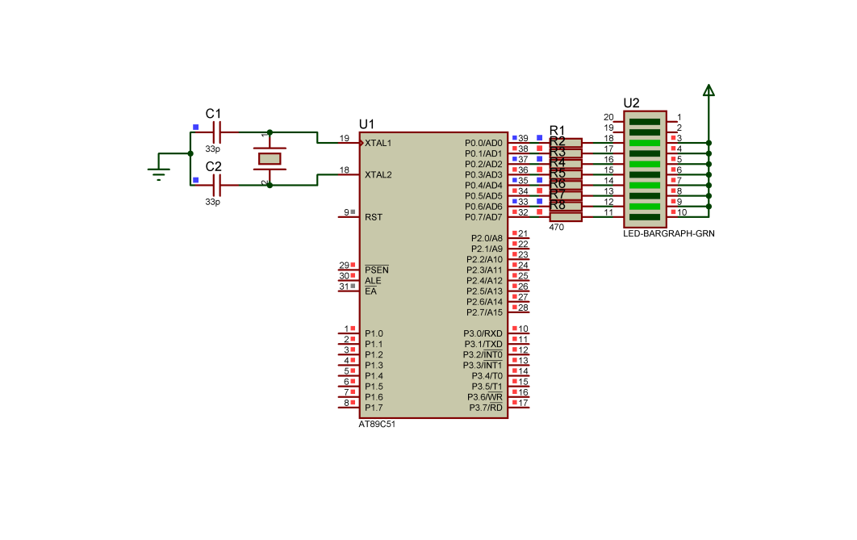

**Figure: Alternating blinking LED**

In this design, use PORT 0 in AT89C51 connection to make LED turn on low state. Because the AT89C51 receives external power, the single LED must receive a low level signal from the AT89C51 to activate.

**Problem 2: Design a single LED communication principle diagram by high-level LED active method**

**Code:**

#include <at89x51.h>

#include <stdio.h>

#define LED0 P1\_0

#define LED1 P1\_1

#define LED2 P1\_2

#define LED3 P1\_3

#define LED4 P1\_4

#define LED5 P1\_5

#define LED6 P1\_6

#define LED7 P1\_7

#define sang 1

#define tat 0

void delay(unsigned int ms)

{

unsigned int i,j;

for(i=0;i<ms;i++)

for(j=0;j<120;j++)

{}

}

void display\_LED(unsigned char number)

{

switch(number)

{

case 1:

LED0 = sang;

LED1 = LED2 = LED3 = LED4 = LED5 = LED6 = LED7 = tat;

break;

case 2:

LED1 = sang;

LED0 = LED2 = LED3 = LED4 = LED5 = LED6 = LED7 = tat;

break;

case 3:

LED2 = sang;

LED1 = LED0 = LED3 = LED4 = LED5 = LED6 = LED7 = tat;

break;

case 4:

LED3 = sang;

LED1 = LED2 = LED0 = LED4 = LED5 = LED6 = LED7 = tat;

break;

case 5:

LED4 = sang;

LED1 = LED2 = LED3 = LED0 = LED5 = LED6 = LED7 = tat;

break;

case 6:

LED5 = sang;

LED1 = LED2 = LED3 = LED4 = LED0 = LED6 = LED7 = tat;

break;

case 7:

LED6 = sang;

LED1 = LED2 = LED3 = LED4 = LED5 = LED0 = LED7 = tat;

break;

case 8:

LED7 = sang;

LED1 = LED2 = LED3 = LED4 = LED5 = LED6 = LED0 = tat;

break;

}

}

void main()

{

unsigned char m;

while(1)

{

for(m=0;m<9;m++)

{

display\_LED(m);

delay(500);

}

}

}

**Schematic:**

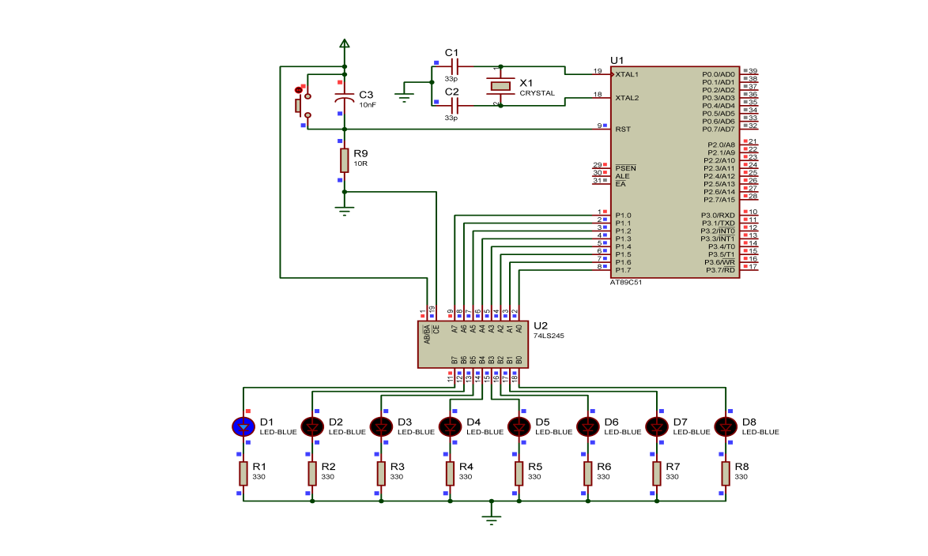

Figure : Single LED interface with latch circuit

We use PORT 0 and PORT 2 to display 7-segment LED and PORT 0 deals with as unit number and PORT 2 is a tens number.

We create an array containing hexadecimal numbers to output 7-segment LED according to PORT 0 and PORT 2. Next we have 2 7-segment LEDs for units and tens to decode and display. Decoders are often used to distinguish between units and decimal numbers by dividing the remainder and the corresponding quotient.

1. **7 segment LED**

**Problem 1: Direct connection method, connect to common Anode 7-segment LED.**

**Code:**

#include<at89x51.h>

#define uchar unsigned char

#define uint unsigned int

void delay\_ms(uint x);

void giaima(void);

void hienthi(void);

uchar donvi,chuc;

uint i,j,a;

int dig[]={0xC0,0xF9,0xA4,0xB0,0x99,0x92,0x82,0xF8,0x80,0x90};

void main(void)

{

while(1)

{

for(i=0;i<100;i++)

{

a=i;

for(j=0;j<5000;j++)

{

giaima();

hienthi();

}

}

}

}

void delay\_ms(uint x)

{

uchar k;

while(x-->0)

{

for(k=0;k<125;k++)

{}

}

}

void giaima(void)

{

chuc=a/10;

donvi=a%10;

}

void hienthi(void)

{

P0=dig[donvi];

P2=dig[chuc];

}

**Schematic:**

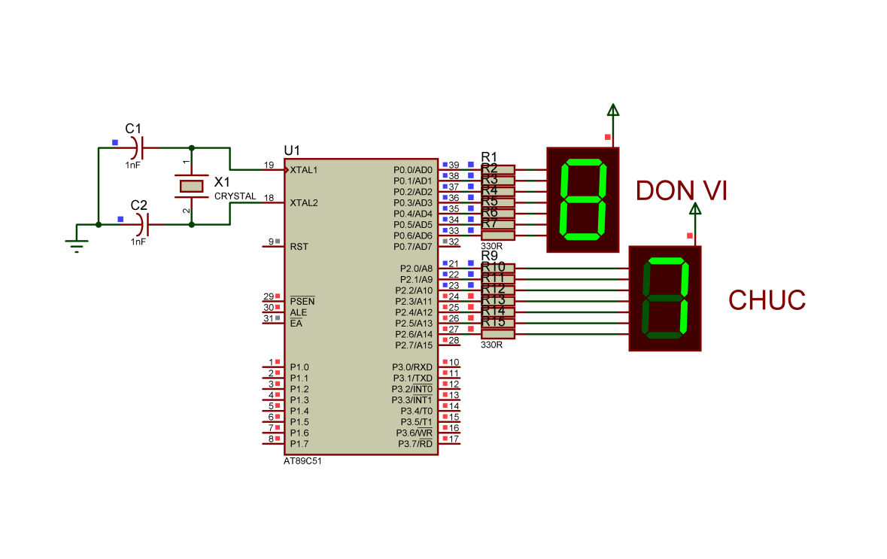

Figure: Design 7-segment LED

We use PORT 0 and PORT 2 to display 7-segment LED and PORT 0 deals with as unit number and PORT 2 is a tens number.

We create an array containing hexadecimal numbers to output 7-segment LED according to PORT 0 and PORT 2. Next we have 2 7-segment LED for units and tens to decode and display. Decoders are often used to distinguish between units and decimal numbers by dividing the remainder and the corresponding quotient.

**Problem 2: Connection method using decoder, connect to 7 segment LED**

**common anode. IC 74LS47 and IC 7446 are decoding from BCD code to 7-segment code.**

**Code:**

#include <at89x51.h>

int dem=0;

void delay(unsigned long time)

{

unsigned long i;

for(i=0;i<time;i++);

{}

}

void main(void)

{

P2=0x00;

while(dem<10)

{

P2=dem;

dem++;

delay(10000);

}

}

**Schematic:**

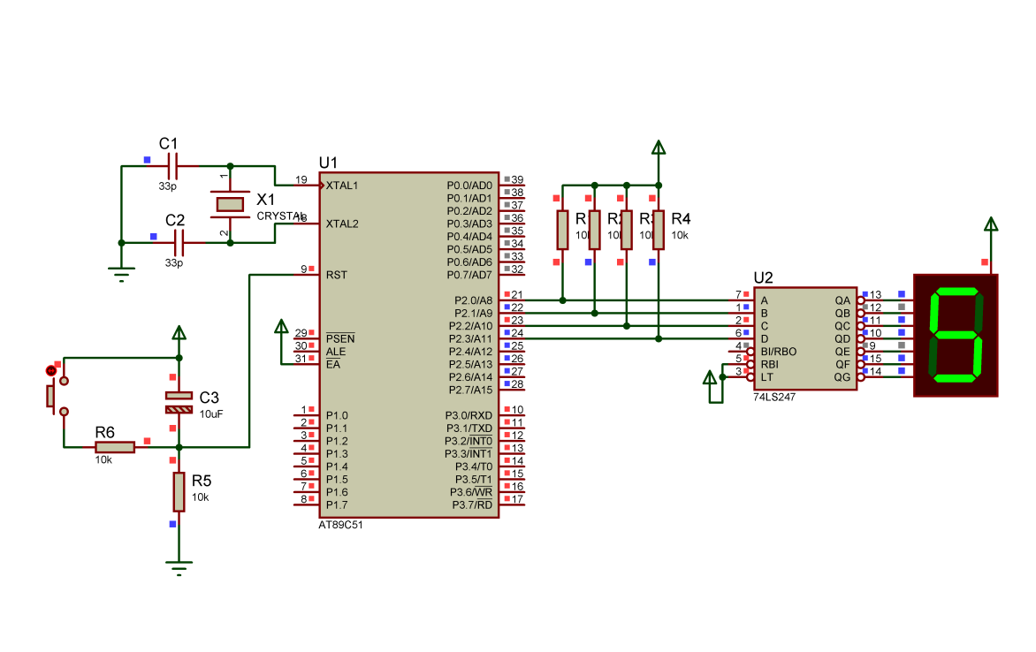

Figure: Display 7-segment LED by IC 74LS247 Decoder

In this case, we use IC 74LS247 decoder, the encoder programming is easier than direct connection in problem 1, so we just need to create a count function from 0 to 9 in PORT2 and IC 74LS247 will automatically decode to decimal and displayed by 7-segment LED.

**Problem 3: Direct connection method combines scanning for multiple 7-segment LEDs. Use LED scanning method to display.**

**Code:**

#include <at89x51.h>

#include <stdio.h>

#define DELAYTIME 65000

unsigned int temp1;

void delay(unsigned int temp)

{

while(--temp);

}

void main()

{

P1=0; //LED is off

while(1)

{

P1=1;

P2=0XC0;

temp1 = DELAYTIME;

delay(temp1);

P1 = 2;

P2 = 0XF9;

temp1 = DELAYTIME;

delay (temp1);

P1 = 4;

P2 = 0XA4;

temp1 = DELAYTIME;

delay(temp1);

P1 = 8;

P2 = 0XB0;

temp1 = DELAYTIME;

delay (temp1);

P1 = 1;

P2 = 0X99;

temp1 = DELAYTIME;

delay (temp1);

P1 = 2;

P2 = 0X92;

temp1 = DELAYTIME;

delay (temp1);

P1 = 4;

P2 = 0X82;

temp1 = DELAYTIME;

delay (temp1);

P1 = 8;

P2 = 0Xf8;

temp1 = DELAYTIME;

delay (temp1);

P1 = 1;

P2 = 0X80;

temp1 = DELAYTIME;

delay (temp1);

P1 = 2;

P2 = 0X90;

temp1 = DELAYTIME;

delay (temp1);

P1 = 4;

P2 = 0X08;

temp1 = DELAYTIME;

delay (temp1);

P1=8;

P2=0X03;

temp1 = DELAYTIME;

delay (temp1);

P1 = 1;

P2 = 0X46;

temp1 = DELAYTIME;

delay (temp1);

P1 = 2;

P2 = 0X21;

temp1 = DELAYTIME;

delay (temp1);

P1 = 4;

P2 = 0X06;

temp1 = DELAYTIME;

delay (temp1);

P1 = 8;

P2 = 0X0E;

temp1 = DELAYTIME;

delay (temp1);

temp1 = DELAYTIME;

delay (temp1);

}

}

**Schematic:**

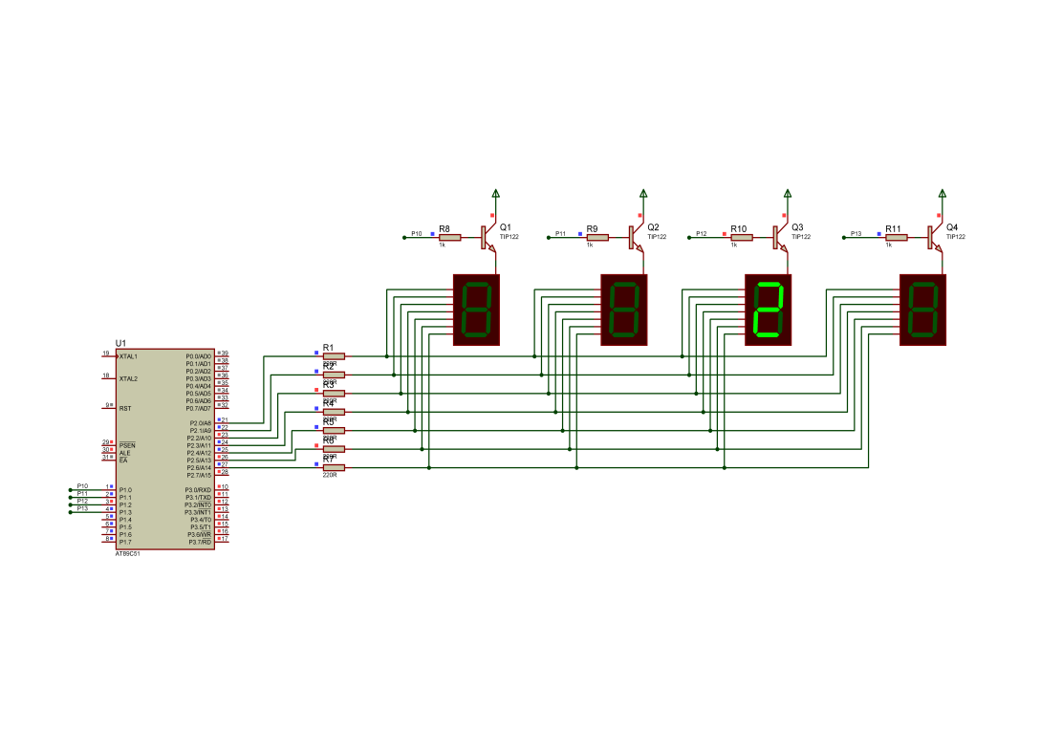

Figure: Display 7-segments LED by scan method

We use PORT 1 and PORT 2. At PORT2, the signal hexadecimal is exported to 7-segment LED while PORT1 use to turn on or off 7-segment LED which are powered through CMOS NPN. when we set variable P1.0 = 0, CMOS NPN receives a signal high level and makes the transistor of the gate is closed to transmit the source to the common anode of the 7-segment LED. And then, we will display the expected number by giving signal from PORT 2 to 7-segment LED and use PORT 1 to select the channel to show it.

**Problem 4: The method combines LED scanning and using IC 74245**

**Code:**

#include <at89x51.h>

void delay()

{

int i;

for(i=1;i<200;i++);

}

unsigned char num[10] = {0xC0,0xF9,0xA4,0xB0,0x99,0x92,0x82,

0xF8,0x80,0x90};

void main()

{

int x,m,n,j,i = 0;

unsigned char p0;

while(1)

{

i=0;n=0;m=0;j=0;

for(m=0;m<10;m++)

for (n=0;n<10;n++)

for (i=0;i<10;i++)

for (j=0;j<10;j++)

for(x=100;x>0;x--)

{

P0 = num[j];

P1 = 0xfe;

delay();

P1 = 0xff;

P1 = 0xfd;

P0 = num[i];

delay();

P1 = 0xff;

P1 = 0xfb;

P0 = num[n];

delay();

P1 = 0xff;

P1 = 0xf7;

P0 = num[m];

delay();

P1 = 0xff;

}

}

}

**Schematic:**

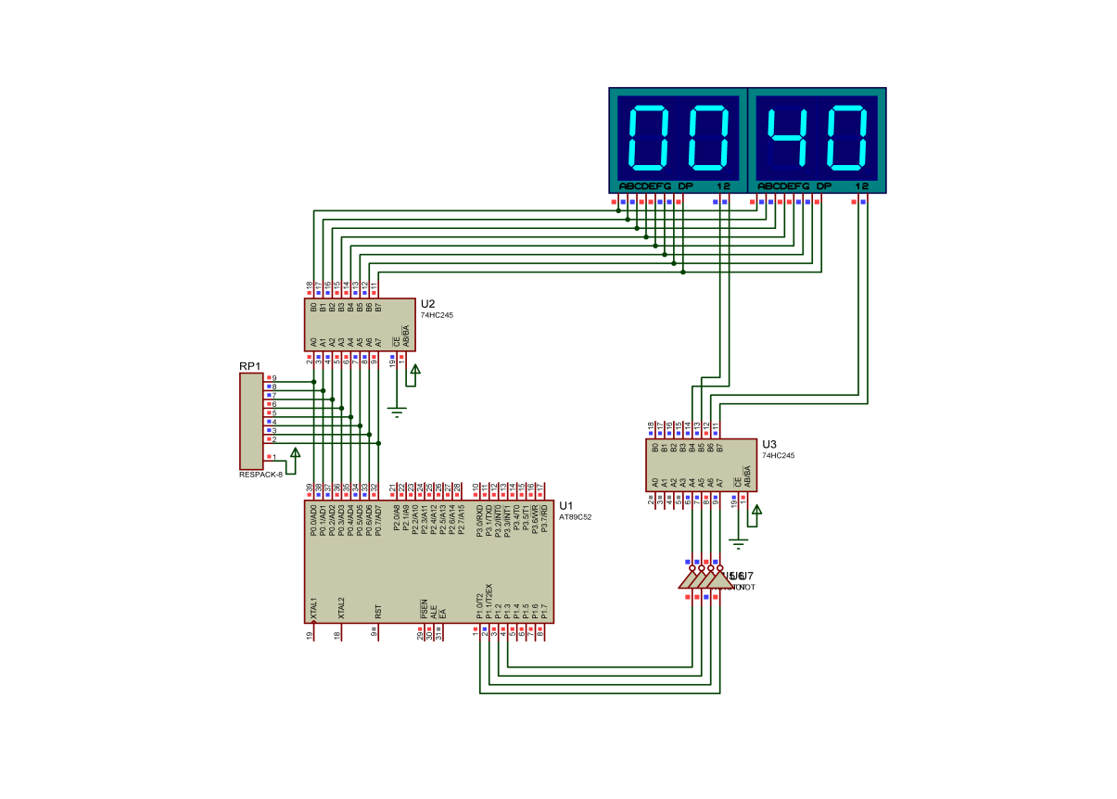

Figure: Scanning 7-segment LED by IC 74245

In this case, we combine IC 74LS245 and AT89C51 to scan 7-segment LED in the circuit. As we can see, IC AT89C51 uses PORT 1.0 - 1.3 to choose to turn on / off each 7-segment LED while PORT 0 transmits the signal to the input of 7-segment LED to display.

We create an array containing hexadecimal numbers to display to 7-segment LED according to PORT 0 and PORT 2. Next, we use the method in problem 2 and 3 to scan the 7-segment LED sequentially but in the lesson. In problem 4, we apply IC 74LS245 for low signal operating through NOT GATE. When outputting data from PORT 0 into 7-segment LED, PORT 1.0-1.3 is selected continuously to turn on/off each 7-segment LED because IC 74LS245 activates low. Finally, we repeat this process continuously to scan the 7-segment LED.

1. Discuss

To connect IC AT89C51 with peripherals there are 2 ways: problem 1 shows us how to display LED directly connected to AT89C51 and problem 2 uses latch circuit to hold and output signal by IC 74LS245 at high level.

Problems 1 and 2 show us how to directly connect a 7-segment LED to IC AT89C51.

Problems 3 and 4 show us how to connect 7 segments by scanning and using IC 74LS245 to buffer the current in the circuit. In the scanning method, we can reduce the number of ports connected by peripheral devices such as 7-segment LED, single LED,…

WEEK 12:

1. Objective

Introduce the method of switching switch with the microcontroller to input the push button input peripheral.

Introduction to matrix keyboard communication method with microcontroller.

Introduction to peripheral communication methods using external interrupts.

Introduces a method to use a timer timer to generate an accurate delay.

1. Requirements

Understand the difference between the communication method because it uses the concept of INTERRUPT Understand the machine cycle (MC) and the combination of MC with TIMER to create delay.

Design a simple firmware program using the high-level C programming language for the 8051 family (computer-on-chip) microcontrollers to apply INTERRUPT and TIMER programming.

1. Design and Implementation

Connect peripherals.

7 segment LED status display by push button.

Single LED display by switch button.

Use interrupts to check the state when a single LED is changed.

Use an external interrupt to increase the value of the LED.

Generate precise delay using Timer/Interrupt.

1. Results (code & schematic)

**Problem 1: Push button method. When button B2 (input P1.0) is 0.**

**Code:**

#include <at89x51.h>

void delay(int interval)

{

int i,j;

for(i=0;i<255;i++)

{

for(j=0;j<interval;j++);

}

}

void main()

{

while(1)

{

//Kiem tra trang thai chan P1\_0 (dau voi cong tac)

if(P1\_0 == 1)

{

P0=0x55;

delay(10);

P0=0xAA;

delay(10);

}

}

}

**Schematic:**

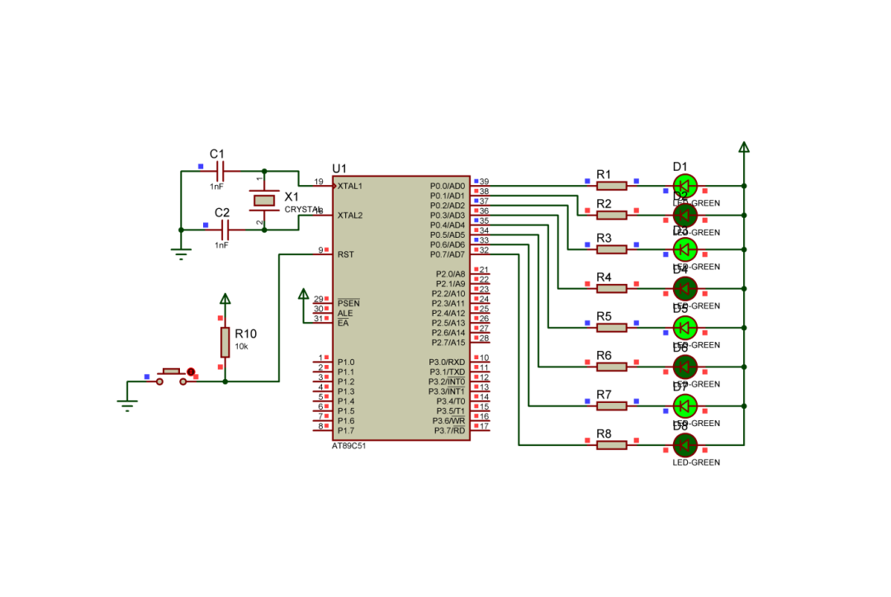

Figure: AT89C51 and Button

We can see that that button has an important role in changing the state of every LED. When we turn on / off the button, the 7-segment LED will change immediately according to the preset.

**Problem 2: Display single LED by switching button**

**Code:**

#include <at89x51.h>

void main()

{

unsigned char temp;

P1=0XFF;

P2=0XFF;

while(1)

{

temp=P2;

P1=temp;

while(P2==temp);

}

}

**Schematic:**

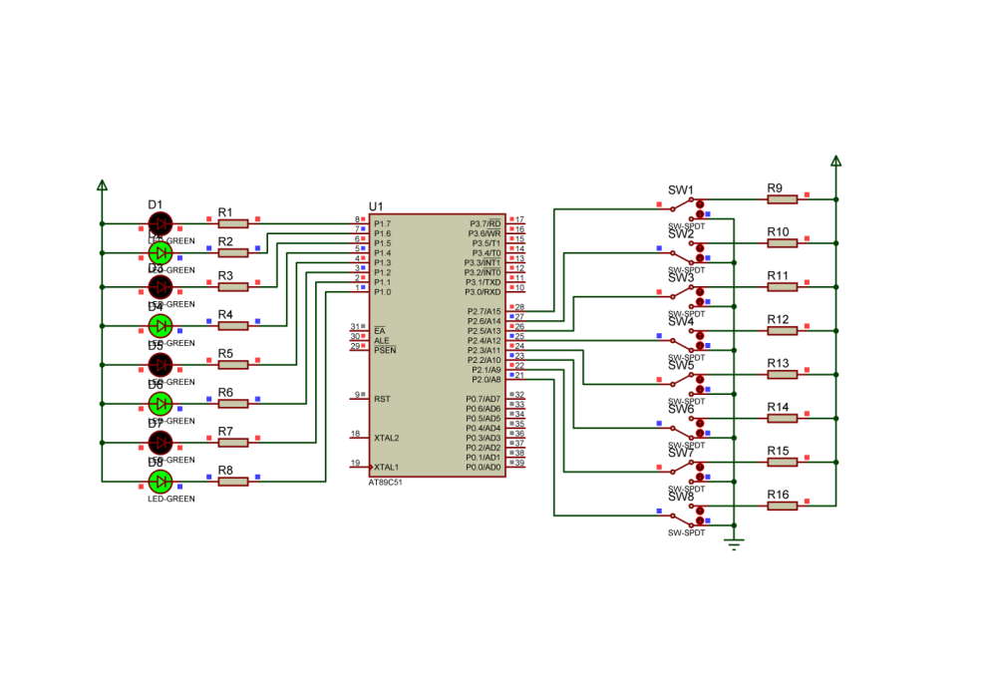

Figure: AT89C51 and Switch

We set up 8 switches to change value of single led that based on low and high levels of the input data of IC AT89C51.

**Problem 4: Apply interrupt and display 7-segment LED**

*Case 1: Using interrupts to check state when single LED is changed.*

**Code:**

#include <AT89X51.H>

void SetupEx0(void);

void main(void)

{

SetupEx0();

while(1);

}

void SetupEx0(void)

{ EA=0;

IT0 = 1;

EX0=1;

EA = 1;

}

void Ex0Isr(void)

interrupt 0

{

P1\_0 = !P1\_0;

}

**Schematic:**

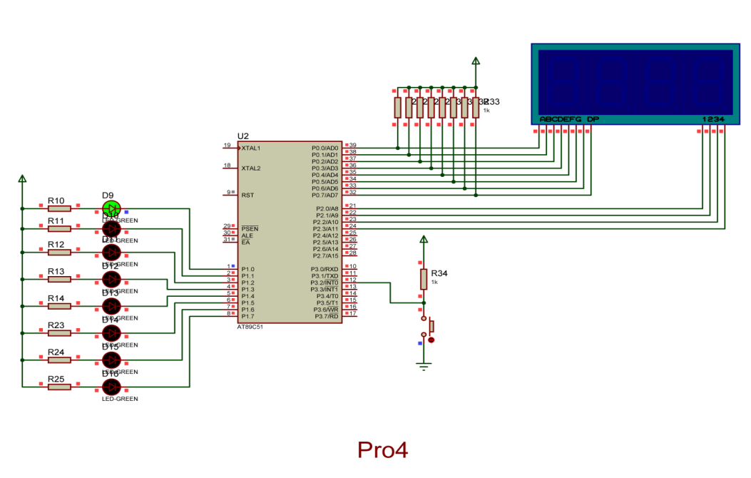

Figure: Using interrupts to check state when single LED is changed

We connect PORT 3.2 with button and PORT 3.2 and 3.3 is one of interrupt mode which to setup to interrupt when it receives a signal data.

*Case 2: Using external interrupt to increase the value of LED.*

**Code:**

#include <at89x51.h>

int count=0;

void delay(int interval)

{

int i,j;

for(i=0;i<100;i++)

{

for(j=0;j<interval;j++);

}

}

void output\_7seg(unsigned char value)

{

unsigned char const

mask[10]={0xC0, 0xF9, 0xA4, 0xB0, 0x99, 0x92, 0x82, 0xF8, 0x80, 0x90};

if(value < 10)

{

P0=mask[value];

}

}

void EXT0\_Process() interrupt 0

{

EA=0;

count++;

EA=1;

}

void display\_number(int iNum)

{

int i;

unsigned char pos=0x08;

unsigned char temp;

for(i=0;i<4;i++)

{

temp=iNum%10;

iNum=iNum/10;

P2=pos;

output\_7seg(temp);

delay(5);

pos=pos>>1;

}

}

void init()

{

P3\_2=1; //Thiet lap chan P3\_2 lam chan vao

IE=0x81; //Cho phep ngat ngoai

IT0=1; //Ngat theo suon

}

void main()

{

init();

while(1)

{display\_number(count);}

}

**Schematic:**

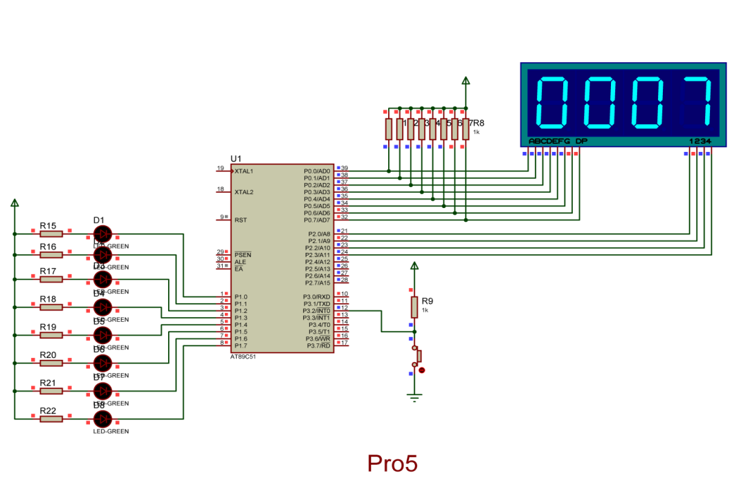

Figure: Using external interrupt to increase the value of LED

We create an array containing the hexadecimal of the 7-segment LED and an external interrupt function. We configure the external interrupt mode by “void init ( )” and count the value when INT0 receives signal data by “void EXT0\_Processes ( )”. Next, we need a function to display the 7-segment LED on the screen as “void display\_number (int iNum)”. Finally, when the button is pressed, the 7-segment LED will change state.

*Case 3: Creating precise delay using Timer/Interrupt.*

**Code:**

#include <at89x51.h>

//tao do tre chinh xac su dung Timer

void delay\_hardware\_50ms()

{

TMOD=TMOD & 0xF0; //Xoa thiet lap Timer0

TMOD=TMOD | 0x01;

ET0=0; //Khong phat sinh ngat

TH0=0x3C; //Thiet lap gia tri khoi dau la 3CB0

TL0=0xB0; //Tuong duong 15536 he 10

TF0=0; //Xoa co tran timer 0

TR0=1; //Khoi dong timer 0

while(TF0==0); //Cho den khi tran

TR0=0; //Dung timer 0

}

//Chuong trinh tao tre chinh xac 1s

void delay\_hardware\_1s()

{

int i;

for(i=0;i<20;i++)

{

delay\_hardware\_50ms();

}

}

void main()

{

while(1)

{

P1=0xAA;

delay\_hardware\_1s();

P1=0x55;

delay\_hardware\_1s();

}

}

**Schematic:**

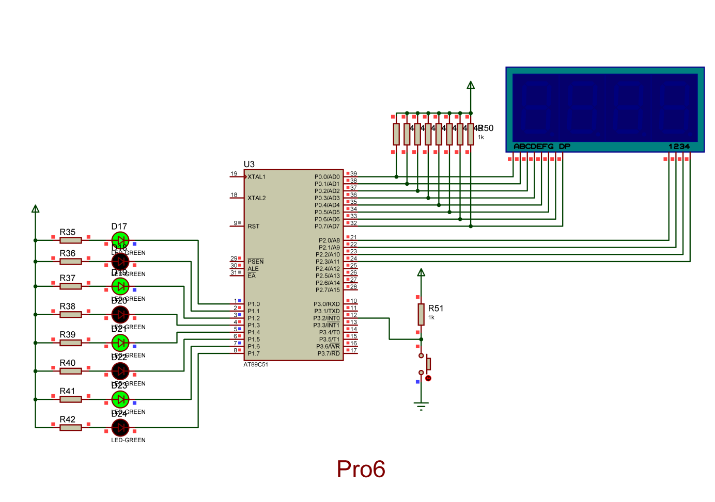

Figure: Creating precise delay using Timer/Interrupt

We use Timer to set delay of LED by any of below steps like:

- First, we have to clear the timer flag 0 and then set it to 1.

- ET0 is used to prevent interrupts from triggering.

- We can set the LED display time according to the timer through setting registers TH0 and TL0. We use the formula T = 1/f to calculate the required delay time.

- From the result of time delay, we attach TH0 and TL0 as desired.

- Set TF0 and TR0 to 0 and 1 respectively to clear the overflow flag and enable the 16-bit timer.

- Check TF0 until it is 1 then set TR0 to 0. TR0 is used to stop 16 bit timer.

- Finally, before the 7-segment LED goes to the next state, it must wait for a time delay by a timer.

1. Discuss

In this problem, we understand the method of peripheral communication with interrupts and understand machine cycle and combine it with timer to create delay.

Design a simple program using the language high level C programming for microcontrollers.

WEEK 13:

1. Objective

Introduction to microcontroller communication method and analog to digital converter (ADC).

Introduce some simple applications with the ADC0809.

1. Requirements

Understand the communication method between the microcontroller and the ADC analog-to-digital converter.

Design a simple firmware program using the high-level C programming language for 8051 family microcontrollers (computers on a chip) to communicate with the ADC.

1. Design and Implementation

ADC0808 has 8 output data, 3 chip select data to get channel, OE is open enable, clock pulse, 1 bit START, 1 bit ALE that allow to read input data to output data , VREF and 8 input data as temperature, voltage,…

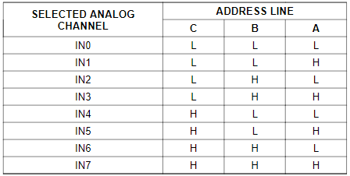

Figure: Analog Channel Selection

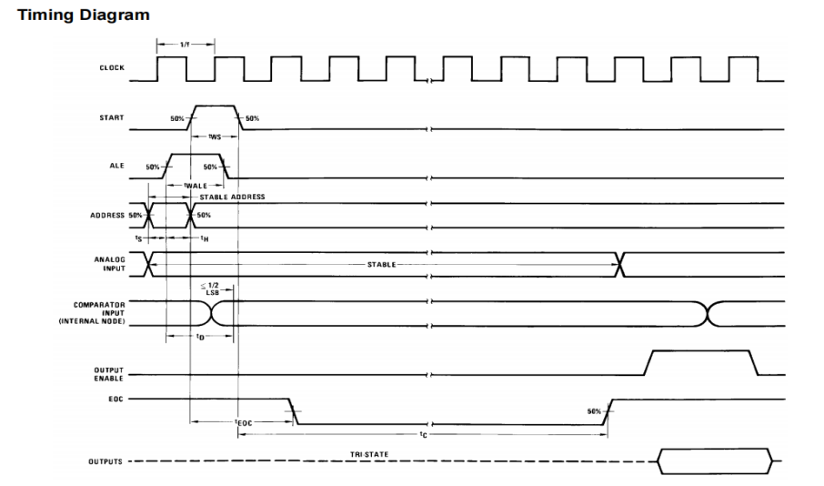

Figure: Time diagram

Formula of converter:

- Step size(Dmin) =

- The output code N :

N = $\frac{Vin }{Vref(+) − Vref(−)}.2^{n}(bit).+/−(Absolute Accurate)$

Note:

- Total Unadjusted Error: ±½ LSB and ±1 LSB

1. Results (code & schematic)

**Problem 1: Survey operation on analog to digital converter ADC.**

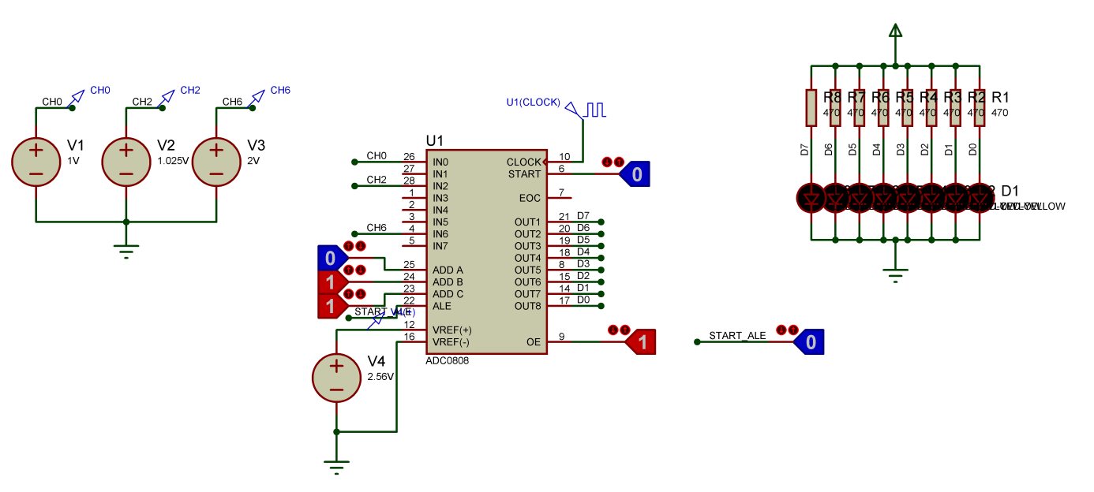

Figure : Analog to digital converter ADC

**Problem 2: Analog to Digital Converters and sensor temperature LM35**

**Code:**

#include <regx51.h>

#define uchar unsigned char

#define uint unsigned int

#define port0 P0

#define ale P1\_0

#define a P1\_1

#define b P1\_2

#define c P1\_3

#define oe P1\_4

#define eoc P1\_5

#define start P1\_6

Int dig[]={0xC0,0xF9,0xA4,0xB0,0x99,0x92,0x82,0xF8,0x80,

0x90};

uchar tram,chuc,donvi;

uint x;

void delay(int x)

{

int i;

for(i=0;i<x;i++);

}

void tachso(void)

{

tram=x/100;

chuc=(x/10)%10;

donvi=x%10;

}

void giaima(int x)

{

if (x==1)

{c=0;b=0;a=0;}

if (x==2)

{c=0;b=0;a=1;}

if (x==3)

{c=0;b=1;a=0;}

if (x==4)

{c=0;b=1;a=1;}

if (x==5)

{c=1;b=0;a=0;}

if (x==6)

{c=1;b=0;a=1;}

if (x==7)

{c=1;b=1;a=0;}

if (x==8)

{c=1;b=1;a=1;}

}

void main()

{

int i;

oe = 1;

for(i=0;i<8;i++)

{

int tam;

for(tam=0;tam<30;tam++)

{

P2=0x01;

P0=dig[i+1];

P2\_4=0;

delay(1000);

start=0;ale=0;eoc=1;

giaima(i+1);

delay(100);

start=1;ale=1;

delay(500);

start=0;ale=0;

while(eoc==0);

delay(100);

eoc=1;

x=P3;

tachso();

P2=0x02;

P0=dig[tram];

P2\_4=1;

delay(500);

P2=0x04;

P0=dig[chuc];

P2\_4=1;

delay(500);

P2=0x08;

P0=dig[donvi];

P2\_4=1;

delay(500);

}

}

}

**Schematic:**

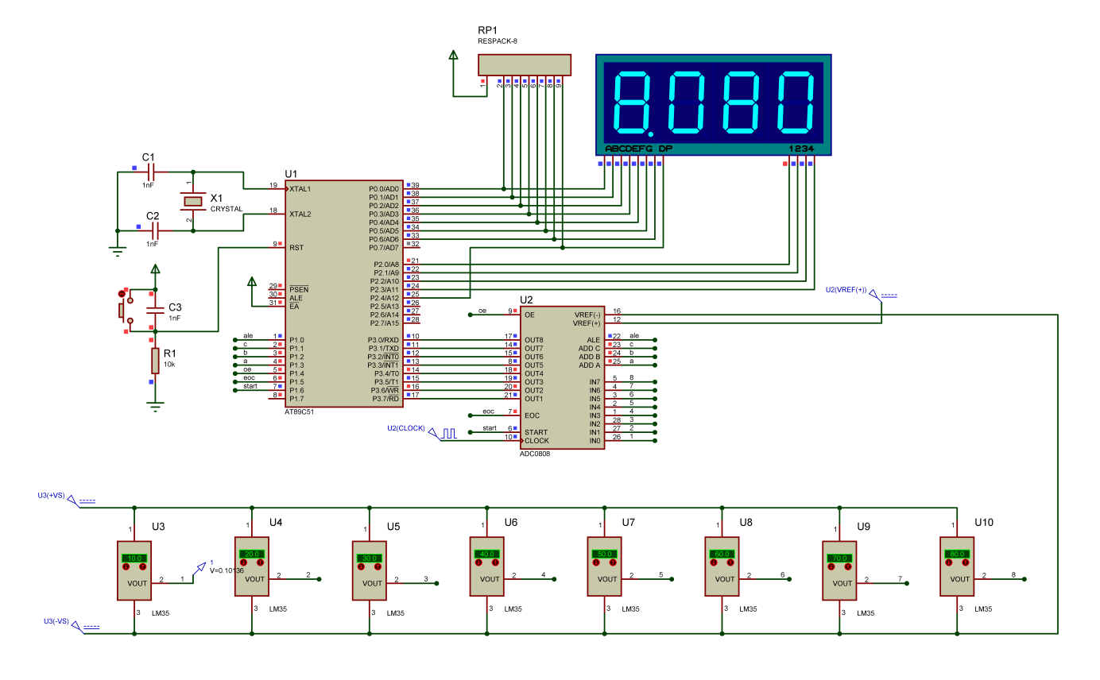

Figure: 8 the sensor temperature LM35 to measure temperature

We have to set the wires as P1.0, P1.4, P1.5, P1.6 and P1.1 to P1.3 using the same ports of IC ADC0808. PORT 3 connects to the output data of ADC0808 (OUT1 - OUT8) and the input data of ADC0808 is linked to 8 temperature sensors.

From the datasheet, the minimum clock frequency in the ADC0808 is 10kHz and goes up to 1280kHz. If we set wrong clock input data in ADC0808, it cannot convert the value of input data to output data. Finally, the circuit will transmit the value of the temperature to display as a 7-segment LED.

1. Discuss

Understand the communication method between the microcontroller and ADC analog.

Design a simple program using the language high level C programming for microcontrollers family 8051 to communicate with ADC.

WEEK 14:

1. Objective

Introduction to microcontroller communication methods using UART asynchronous serial data transmission.

Introduction to basic computer communication applications through the UART transmission standard.

Introduction to the function of MAX232 converter in computer communication.

Introduction to the method of building graphical applications (GUI) controlled from the computer.

1. Requirements

Understand the communication method between microcontroller and general purpose computer via UART.

Design a simple firmware program using the high-level C programming language for the 8051 family of microcontrollers (computer on chip) combined with a GUI using C# to communicate with the computer as well as other microcontrollers.

1. Design and Implementation

In this problem, we use 2 software Virtual Serial Port Driver and H-Term to simulate.

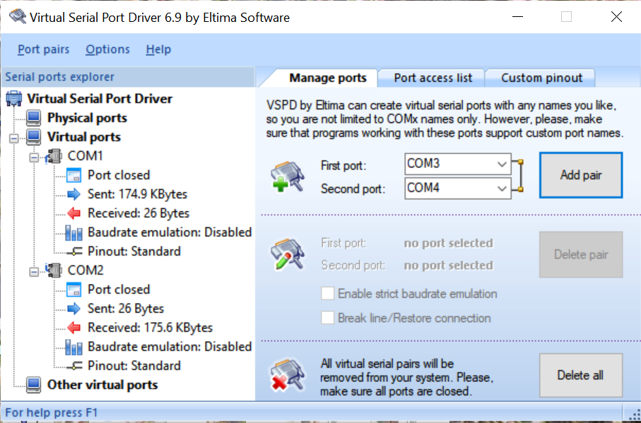

Figure: Virtual Serial Port Driver Software

The Virtual Serial Port Driver help the user create Virtual Port such as COM1 and COM2 communication if they don’t have Physical Port.

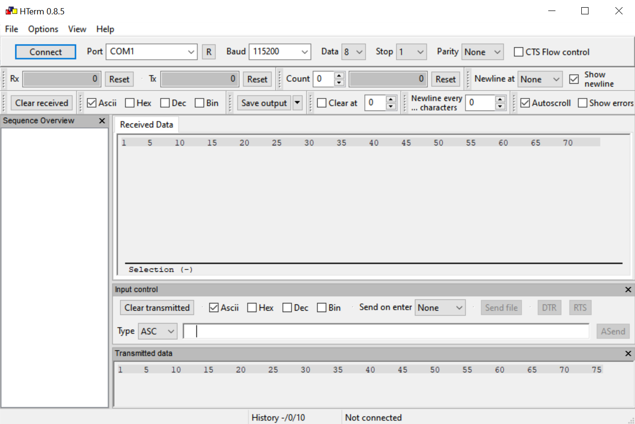

Figure: H-Term.

H-Term Software is a middleware that helps 2 ports as COM1 and COM2 connect to each other.

1. Results (code & schematic)

**Code:**

#include <at89x52.h>

unsigned char chuc, dvi, rdata, nhietdo;

void setup()

{

TMOD = 0x20;//;enabletimer1,mode2(autoreload)

TH1 = -3; //9600Baudrate

SCON = 0x50;//;8bituart,1stop bit,RENenabled,timer1

TR1 = 1;

IE = 0x90;

}

void serint(void)interrupt 4 using 1

{

if(RI)

{

rdata = SBUF;

RI = 0;

switch(rdata)

{

case('0'):{P0\_7 = 0; break;}

case('1'):{P0\_7 = 1; break;}

case('a'):{TH1 = -24; break;}

case('b'):{TH1 = -12; break;}

case('c'):{TH1 = -6; break;}

case('d'):{TH1 = -3; break;}

}

}

}

void main()

{

unsigned char trans\_data;

setup();

while(1)

{

nhietdo = P1;

chuc = (nhietdo/10)<<4;

dvi = nhietdo%10;

P2 = chuc|dvi;

trans\_data = P2;

SBUF = trans\_data;

while(TI == 0);

TI = 0;

}

}

**Schematic:**

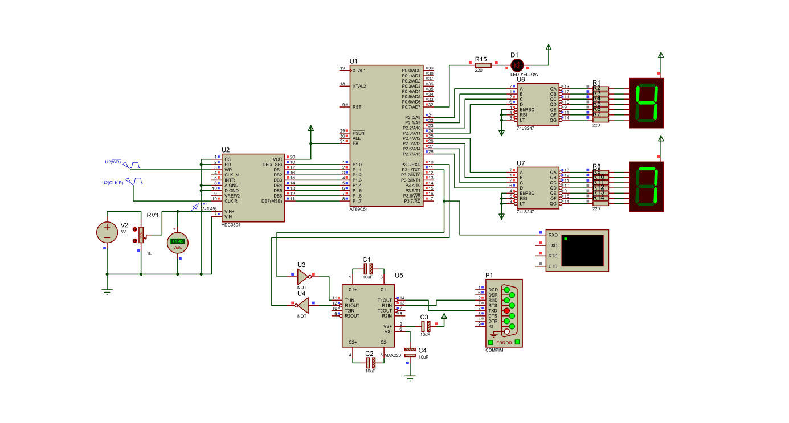

Figure : UART application

Through the above 2 software, we can transmit and send data back and forth and output the sent data value displayed on the 7-segment LED.

In this problem, we use the temperature read AT89C51 of ADC0804 and display it in 7-segment LED. The problem will show you how the UART connects the circuit using a single LED that is activated for identification.

1. Discuss

We have interfaced microcontroller using UART, basic computer communication via UART transmission standard, and understood the function of MAX232 converter in computer communication.

REFERENCES

1. Datasheet: AT89C51, ADC0808, Max232, LM35
2. William Stallings, Computer Organization and Architecture 10th Edition,

<https://vn1lib.org/book/3710986/989b01>

1. Tống Văn On, HỌ VI ĐIỀU KHIỂN 8051,

<https://www.kenhebook.info/2016/03/ho-vi-ieu-khien-8051-tong-van-on-pdf.html>

1. Phạm Văn Khoa, Thực hành Kiến trúc và Tổ chức Máy Tính.
2. Springer, 8051 Microcontrollers: Fundamental Concepts, Hardware, Software and Applications in Electronics, <https://vn1lib.org/book/3512403/23d0b2.>

;Start:

; MOV TMOD, #01H

; MOV TH0, #03CH

; MOV TL0, #0B8H

; SETB TR0

; MOV R0, #0AH

;

;Loop:

; MOV P0, #55h

;JNB TF0, Loop

; CLR TF0

; MOV TH0, #03CH

; MOV TL0, #0B8H

;DJNZ R0, Loop

;;CPL P1.0

;MOV R0, #0AH

;MOV P0, #0aah

;JNB TF0, Loop

; CLR TF0

; MOV TH0, #03CH

; MOV TL0, #0B8H

;DJNZ R0, Loop

;JMP Loop